

**Arab Academy for Science, Technology and Maritime Transport**

**College of engineering and technology**

**Mechanical Engineering**

**B.SC. Final Year Project 2022/2023**

**Advanced driver assistance system (Drowsiness detection)**

**Presented By:**

**Mario Ezzat Keddis**

**Mohamed Ahmed Ismail**

**Mohamed Kamel Mohamed**

**Ahmed Medhat Hafez**

**Ahmed Hamdy Elhossary**

**Omar Hisham Elsherif**

**Supervised By:**

**Prof.Dr. Waleed Ghoniem**

**Dr. Essam Seddik**

# Report Contribution Table

|  |  |
| --- | --- |
| Mario Ezzat Keddis | * Computer Vision literature review * Computer Vision Work * Assembled the components. |
| Mohamed Ahmed Ismail | * ECG literature review * EEG literature review * ECG work * PPG work |
| Mohamed Kamel Mohamed | * PPG literature review * Abstract * Introduction * Acknowledgments |
| Ahmed Hamdy Elhossary | * Cost * EEG literature review |
| Ahmed Medhat Hafez | * References * Conclusion & Future work * ECG literature review |
| Omar Hisham Elsherif | * Computer vision literature review |

# Acknowledgments

We would like to express our sincere gratitude to our supervisors, Prof. Walid Ghonem Head of Electrical Engineering Department, and Dr. Essam Seddik for providing their precious time, guidance, suggestion, and support throughout project 1. We would like to thank Swift Act, our sponsor, especially Eng.Abdelrahman Emad, Eng.Amr Aly, and Eng. George Eskandar for their efforts and for providing us with such a great opportunity. We would also like to thank our department Teacher assistants for constantly motivating and encouraging us. Finally, our parents for their unlimited support and encouragement as well as our friends who supported and motivated us.

# Abstract

Drowsy driving is fatal as it is most frequently associated with unfortunate mistakes. The objective is to create an advanced driving assistance system to alarm and protect the driver in case of drowsiness. Three methods can be used: vehicle-based, behavioral, and physiological measurements. All three methods are mainly non-intrusive and relatively cheap, the physiological method is crucial, primarily based on vital organs activity where drowsiness is detected throughout the driver’s HRV without using a video camera. The behavioral method monitors the EAR of the driver and acts immediately in case the driver is falling asleep. Using computer vision, the video camera inputs the video feed to a face detection algorithm to extract the face. From the extracted face, the eyes are located then EAR patterns are detected to estimate the drowsiness state.

# Table of contents

Report Contribution Table 2

Acknowledgments 3

Abstract 4

Table of contents 5

List of figures 7

List of tables 9

List of Acronyms/Abbreviations 10

1. Introduction 11

2. Literature Review 12

2.1. Drowsiness Detection Computer Vision 12

2.1.1. “A Method of Driver’s Eyes Closure and Yawning Detection for Drowsiness Analysis by Infrared Camera” 12

2.1.2. “Driver’s Fatigue and Drowsiness Detection to Reduce Traffic Accidents on Road” [3] 16

2.2. Drowsiness Detection Using Vital Organs 20

2.2.1. “On-board Drowsiness Detection using EEG: Current Status and Future Prospects.” 20

2.2.2. “Driver fatigue and drowsiness monitoring system with embedded electrocardiogram sensor on steering wheel” 23

2.2.3. “A review on wearable photoplethysmography sensors and their potential future applications in health care” 28

2.3. Safety Features 32

2.3.1. “Detecting Usage of Mobile Phones using Deep Learning Technique.” 32

2.3.2. “Simultaneous Face Detection and Pose Estimation Using Convolutional Neural Network Cascade” 38

2.3.3. “Drowsy Driver Detection via Steering Wheel” 43

3. System Component Candidates 50

3.1. Computer Vision drowsiness detection 50

3.1.1. Eye Aspect Ratio (EAR) 50

3.1.2. Methodology 50

3.1.3. Dlib Face Detection 51

3.1.4. Dlib Facial Landmarks 51

3.1.5. Dlib Pre-processing 51

3.1.6. Data gathering 52

3.1.7. Dlib Results 52

3.1.8. Dlib Custom Eye Predictor Results 52

3.1.9. MediaPipe Landmarks 54

3.1.10. MediaPipe Results 54

3.2. ECG 56

3.2.1. Circuitry 56

3.2.2. Analog Preamplification 56

3.2.3. Analog Signal Filtration 57

3.3. PPG 59

3.3.1. Band design 59

3.3.2. Noise Filtrations 60

3.3.3. IIR Filter 61

3.3.4. Code Concept 61

3.3.5. Testing 62

3.3.6. Concept Description 65

4. Conclusion & Future Work 66

5. Gantt Chart 66

Refrences 67

Bibliography 68

# List of figures

Figure 1: Input image from infrared camera 12

Figure 2: Driver’s face detection and set it to ROI 12

Figure 3: Images after split two half 13

Figure 4: Images titled after split two half 13

Figure 5: Eyes-opening’s HOG & Eyes-closing’s HOG 13

Figure 6: Output when driver is normal 14

Figure 7: Output when driver is Drowsy 14

Figure 8: Proposed and classic edge detectors for eye and mouth regions 17

Figure 9: Driver’s fatigue and drowsiness detection system 17

Figure 10: Results of fatigue and drowsiness detections 19

Figure 11: EEG Detection Cycle 20

Figure 12: EEG Waves 21

Figure 13: EEG Detection Devices 22

Figure 14: Schematic of One Cardiac Cycle 23

Figure 15: HRV Using ECG for Normal State 25

Figure 16: HRV Using ECG for Fatigued and Drowsy State 25

Figure 17: AD8232 ECG Sensor 26

Figure 18: Implementation AD8232 Sensor 27

Figure 19: Capacitive Electrodes by Ford 27

Figure 20: P-P Interval 29

Figure 21: PPG Sensor Implementation Positions on Human Body 30

Figure 22: Sample images from Kaggle Driver dataset 32

Figure 23: Sample images from IITH-DMU 32

Figure 24: Flow Diagram of RPN 33

Figure 25: Architecture of Faster-RCNN 33

Figure 26: Architecture of SSD 33

Figure 27: multi-scale object prediction at (a) inference time (pyramid of images) and (b) at training time (pyramid of feature maps) in FPN 34

Figure 28: Architecture of FPN with bottom-up and top-down pathways 34

Figure 29: Failure cases 37

Figure 30: The CNN framework 38

Figure 31: Corse-detection Net 39

Figure 32: The architecture of improved CNN 39

Figure 33: Comparisons of face detection 40

Figure 34: Pose Estimation cumulative error 41

Figure 35: Comparisons of ROC curves on FDDB with and without joint training 41

Figure 36: Comparisons of ROC curves on FDDB with and without feature fusion 42

Figure 37: Cumulative error distribution curves on AFW with and without feature fusion 42

Figure 38: Landmarks Coordinates 43

Figure 39: EAR 44

Figure 40: Flow Chart 44

Figure 41: The Eye Region 45

Figure 42: Overview Circuit of Amplification and Filtering 46

Figure 43: ECG Pre-Amplifier Circuit 46

Figure 44: ECG Pre-Amplifier Circuit on Proteus 47

Figure 45: Butterworth Filter 47

Figure 46: Butterworth Filter on Proteus 48

Figure 47: Final ECG Circuit on Breadboard 48

Figure 48: PPG Band Concept 49

Figure 49: Max30102 Sensor 49

Figure 50: Signal Noise 51

Figure 51: R - R Method 52

Figure 52: PPG Band Result in Normal State 53

Figure 53:PPG Band Result in Fatigued State 54

Figure 54: PPG Band Result in Drowsy State 54

Figure 55: Our PPG Band 56

# List of tables

Table 1: Face detection accuracy 14

Table 2: Eyes detection accuracy 14

Table 3: Mouth detection accuracy 15

Table 4: Accuracy of eyes closure and yawning detection 15

Table 5: Kappa statistic interpretation 18

Table 6: Statistical measures of fatigue and Drowsiness detections 18

Table 7: BPM Values of AD8232 Sensor 26

Table 8: Characteristics of datasets 35

Table 9: Results on COCO 35

Table 10: Results on two datasets 36

Table 11: Coordinates of various facial regions 43

Table 12: BPM Results 55

Table 13: BPM Data Chart 55

# List of Acronyms/Abbreviations

Circle Hough Transform

CHT 15

Correct Classification Rate

CCR 17

Electrocardiogram

ECG 10

Electroencephalogram

EEG 10

Electromyography

EMG 10

Electrooculography

EOG 10

Frames Per Second

FPS 17

Heart Rate Variability

HRV 22

Histogram of Oriented Gradients

HOG 12

National Highway Traffic Safety Administration

NHTSA 10

Non-Rapid Eye Movement

NREM 19

Otorhinolaryngology

ORL 17

Photoplethysmography

PPG 10

Power Spectral Density

PSD 20

Rapid Eye Movement

REM 19

Region of Interest

ROI 11

Support Vector Machine

SVM 12

# Introduction

Drivers can carelessly drive while feeling drowsy without looking forwards to the consequences. Unfortunately, without considering safety measures, drivers do not recognize their lack of concertation or exhaustion until it is too late. according to the Central Agency for Public Mobilization and Statistics, due to drowsiness and other various reasons, the number of injuries due to road accidents in Egypt reaches 51,511 in 2021 compared 56,789 in 2020 and the number of deaths reaches 7,101 every year, Road accident injuries, according to the road user, came first (passengers) with 17,805 injured, followed by (pedestrians) with 12,948 injured in 2021 [1]. Hence, a drowsiness detection system is highly needed to protect drivers as well as pedestrians and reduce a huge number of crashes. That’s where the advanced driving assistance system comes in handy as it aims to protect the driver and reduce the huge number of crashes almost on the daily basis.

Drowsiness is the same as being sleepy, which is just another word for having a tendency to sleep. The sleep stages can be specified into REM, NREM, and awake. Where the second stage can be subdivided into:

Stage 1: Transition from being awake to falling asleep.

Stage 2: Light sleep

Stage 3: Deep sleep

There are various methods to detect driver drowsiness, the most common ones are vehicle-based, behavioral, and physiological measurements. The first method is vehicle-based which estimates a number of metrics, such as lane position deviations, steering wheel movement, and pressure on the acceleration pedal. The second method is behavioral, where a camera is used to monitor the driver’s behavior, such as eye closure, yawning, head pose, and eye blinking. The third method is physiological which detects the driver’s state using Vital organs, such as; EEG, ECG, PPG, EOG, and EMG. Using these three methods, any change that exceeds a predetermined threshold indicates a highly increased chance that the driver is fatigued. Then the driver is warned if any of these drowsiness signs are detected.

To create an effective drowsiness detection system, the benefits of each existing method can be combined into a hybrid system, but some methods can have severe limitations and drawbacks such as the vehicle-based method which are:

1. High-cost installation.
2. Hard to apply in all cars.
3. Inaccurate

# Literature Review

## Drowsiness Detection Computer Vision

### “A Method of Driver’s Eyes Closure and Yawning Detection for Drowsiness Analysis by Infrared Camera”

In this paper, the method to detect driver’s eyes closure and yawning for drowsiness analysis by an infrared camera [2].

#### The Proposed Method

The main concept is detecting the driver’s face and setting it to a ROI. Next use ROI to find targets such as eyes and mouth. This process starts from getting input from an infrared 2D camera and processing by MATLAB R2015a. The flow chart has five steps:

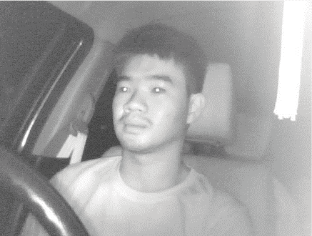

Figure 1: Input image from infrared camera

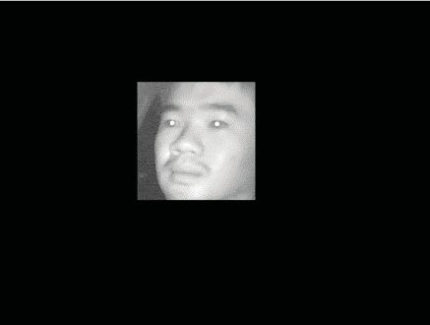

Figure 2: Driver’s face detection and set it to ROI

1. **Input image from infrared**

Install a camera in the middle of the car’s console. Facing approximately 15 degrees to the driver’s face. The frame rate is set as 25 frames per second and the input scale is 200×200 pixels.

1. **Face detection**

The Haar-like feature is one of the methods that has the ability to detect faces. This step uses to make (ROI) for finding the driver’s face. Harr-like feature is the method classify the dominant face by determining the differential of shading rectangle and normal rectangle and comparing it with threshold and polarity.

1. **Split image to upper-half and lower-half**

This method limits the scope of detecting the driver’s eyes and mouth.

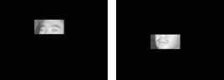

Figure 3: Images after split two half

1. **Detecting driver’s eyes and mouth**

The driver’s image will be a little tilted, so this step will rotate the image approximately 3 degrees to the left and right.

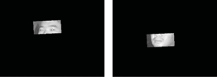

Figure 4: Images titled after split two half

1. **Detecting eyes closure and yawning**

Using a SVM. Before training data to SVM normal images must be turned into vector data by extracting the HOG. HOG is a method that separates images into many cells and collects histogram from every single gradient and calculates the scale and vector of that cell. HOG is the vector of each pixel. There are 2 groups of data like eyes opened and eyes closed.

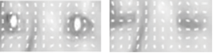

Figure 5: Eyes-opening’s HOG & Eyes-closing’s HOG

#### Experiment Result

This work has four experiments such as:

1. Face detection
2. Eyes detection
3. Mouth detection
4. Eyes closure and yawning detection

The driver would random action symptoms of driver drowsiness for example blink a lot, close driver eyes, and yawn randomly. These experiments do in low-light situations with 4 volunteers.

The program will print a green rectangle around the eyes and mouth area. When the program can detect symptoms of driver drowsiness program will print a red rectangle at the symptom area.

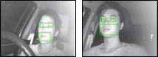

Figure 6: Output when driver is normal

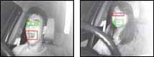

Figure 7: Output when driver is Drowsy

Table 1: Face detection accuracy

|  |  |  |  |  |  |
| --- | --- | --- | --- | --- | --- |
| Subject | Total frame | Correct frame | Error frame | Miss frame | Accuracy |
| 1 | 865 | 865 | 0 | 0 | 100 % |
| 2 | 1041 | 1025 | 2 | 14 | 98.46 % |
| 3 | 1047 | 1043 | 1 | 3 | 99.61 % |
| 4 | 825 | 825 | 0 | 0 | 100 % |
| Total | 3778 | 3758 | 3 | 17 | 99.47 % |

Table 2: Eyes detection accuracy

|  |  |  |  |  |  |
| --- | --- | --- | --- | --- | --- |
| Subject | Total frame | Correct frame | Error frame | Miss frame | Accuracy |
| 1 | 865 | 733 | 33 | 99 | 84.73 % |
| 2 | 1027 | 1004 | 16 | 7 | 97.76 % |
| 3 | 1044 | 986 | 40 | 18 | 94.44 % |
| 4 | 825 | 825 | 0 | 0 | 100 % |
| Total | 3761 | 3548 | 89 | 124 | 94.33 % |

|  |  |  |  |  |  |
| --- | --- | --- | --- | --- | --- |
| **Subject** | **Total frame** | **Correct frame** | **Error frame** | **Miss frame** | **Accuracy** |
| 1 | 865 | 829 | 36 | 0 | 95.83 % |
| 2 | 1027 | 1016 | 11 | 0 | 98.92 % |
| 3 | 1044 | 1003 | 41 | 0 | 96.07 % |
| 4 | 825 | 816 | 9 | 0 | 98.90 % |
| Total | 3761 | 3664 | 97 | 0 | 99.80 % |

Table 3: Mouth detection accuracy

Table 4: Accuracy of eyes closure and yawning detection

|  |  |  |  |  |
| --- | --- | --- | --- | --- |
| Subject | True Positive Rate (Eye) | True Negative Rate (Eye) | False Positive Rate (Mouth) | False Negative Rate (Mouth) |
| 1 | 32.4 % | 96.7 % | 51.0 % | 64.1 % |
| 2 | 92.8 % | 98.6 % | 97.4 % | 96.2 % |
| 3 | 75.4 % | 96.5 % | 77.2 % | 70.5 % |
| 4 | 99.5 % | 98.9 % | 97.7 % | 98.0 % |
| Validation | 98.0 % | 96.0 % | 92.5 % | 92.5 % |

From the experiments accuracy table found that the error of 7.5% in yawning detection is caused by the driver's mouth being open too much, so the program can’t detection are driver yawning. And the error of ROI detection that comes from the camera is set up on the side of the driver, so the camera can’t capture the full driver’s face.

### “Driver’s Fatigue and Drowsiness Detection to Reduce Traffic Accidents on Road” [3]

This paper proposes a robust and nonintrusive system for monitoring drivers’ fatigue and drowsiness in real-time. The proposed scheme begins by extracting the face from the video frame using the SVM face detector. Then CHT is applied on the eyes and mouth extracted regions. The drowsiness analysis method aims to detect micro-sleep periods by identifying the iris using a novel method to characterize the driver’s eye state.

#### Driver’s Drowsiness Analysis

1. **Iris Edge detector**

If the eye is open, viewing three main components:

**The pupil** which is the little black circle in the center of eye.

**The iris** is the circle distinguished by the eye color.

**The sclera** is the white outer area represents.

Iris edge extraction from significant intensity variations between iris and sclera. For each pixel x, a neighborhood containing n pixels at left and right of x is specified.

Left (resp. Right) edge: if n or n − 1 left (resp. right) neighbors of x

provide a difference with x higher than the high threshold and if n or n − 1.

right (resp. left) neighbors of x provide a difference with x lower than the low

threshold, we deduct that x is a left (resp. right) edge pixel of the iris and we

put it at 1.

1. **Drowsiness detection**

Applying the CHT on this edge to obtain the iris radius from which we decide if the eye is open. Then three edge pixels are randomly chosen. and if the distance between each two pixels co-ordinates is higher than a fixed threshold, we compute the radius and the center coordinates of the candidate circle defined by these three pixels. The system stops at maximal iterations or when the edge has few pixels. Drowsiness is dependent on the microsleep periods which needs to be at least 2 seconds.

#### Driver’s Fatigue Analysis

characterized by a high yawning frequency. Because drowsiness occurs sometimes after fatigue. This step to prevent the driver before micro-sleep. Yawning is a wide-open mouth which lasts from 2 to 10 seconds. Applying CHT on mouth edge images.

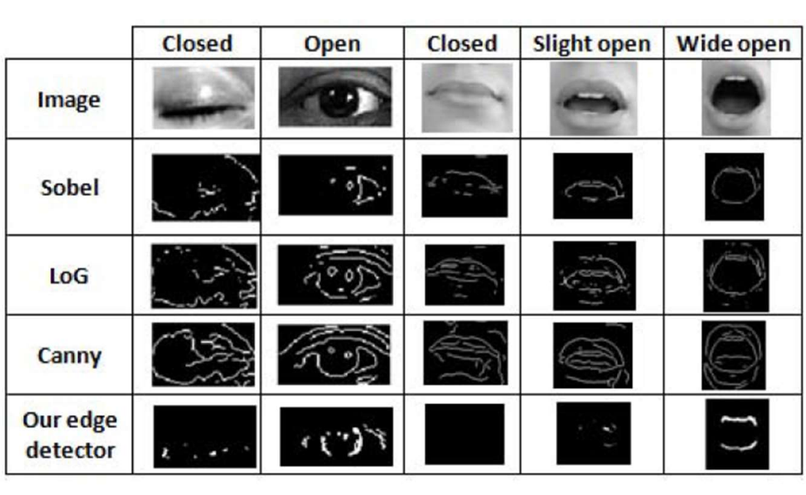

Figure 8: Proposed and classic edge detectors for eye and mouth regions

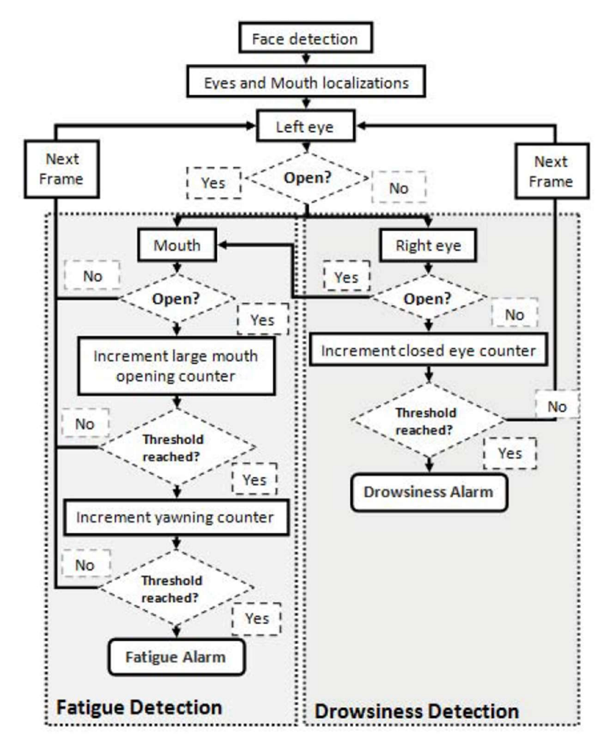

Figure 9: Driver’s fatigue and drowsiness detection system

#### Experimental Results

tests on 18 real video sequences of 14 different subjects in various lighting conditions to validate the proposed system. Webcam connected to a laptop by USB port. providing image of 640x480 at 30 FPS. Reducing the considered number of FPS from 30 to 2, to meet the real-time constraints. The CHT used 173 images of ORL database for evaluation. The accuracy of the first system is 90.3%. The second system presented. CCR is 94% and the average of κ is 86%. The second system uses 70 images using infra-red camera with 90% accuracy. On real images yawning detection is reduced to 81% accuracy.

Table 5: Kappa statistic interpretation

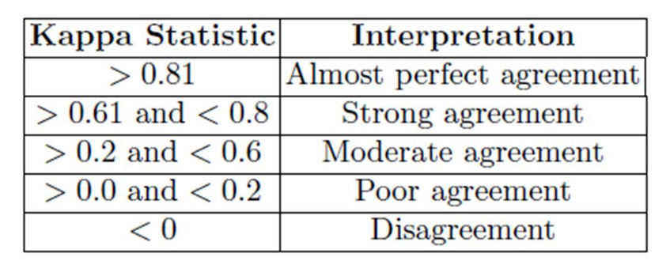

Table 6: Statistical measures of fatigue and Drowsiness detections

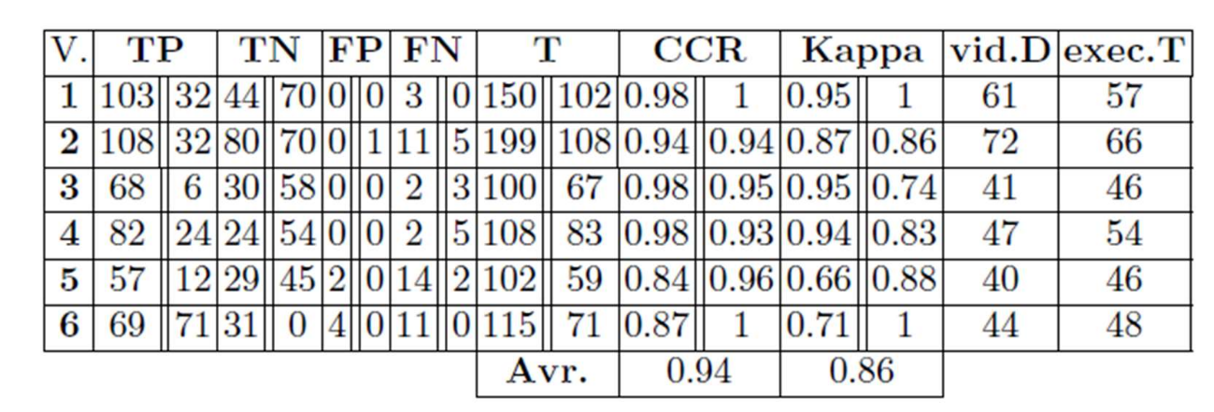

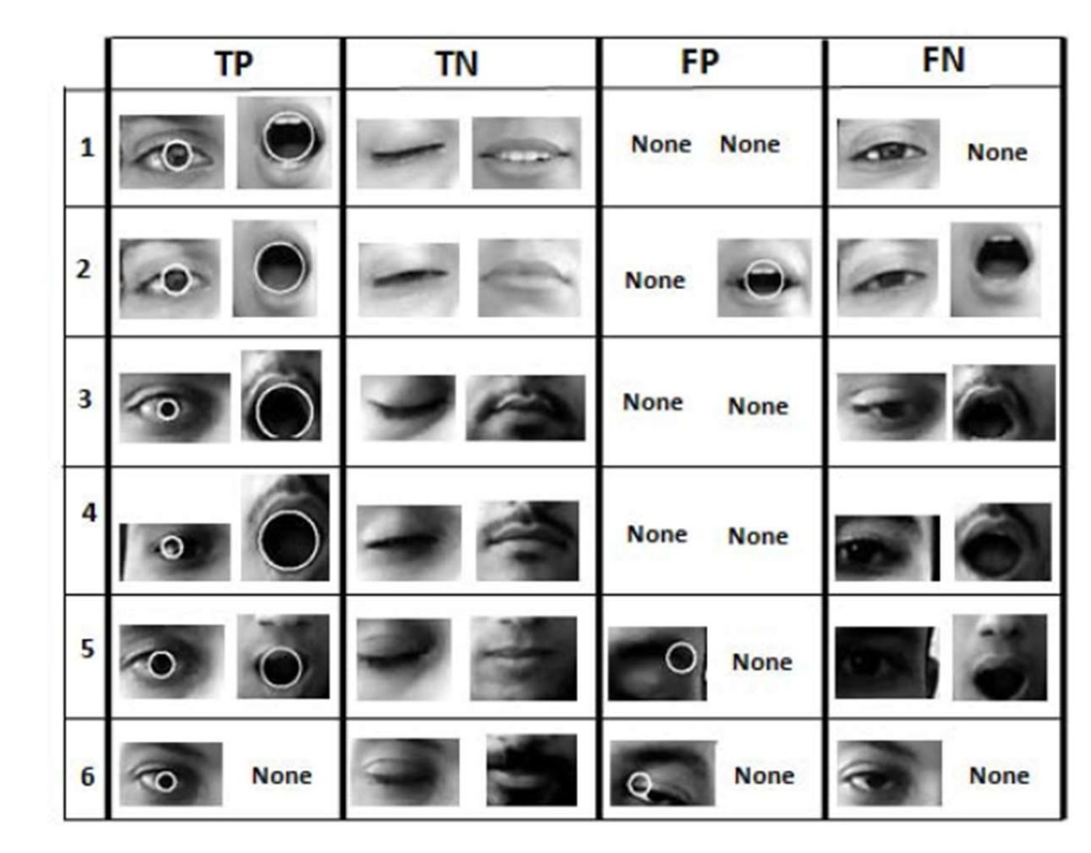

Figure 10: Results of fatigue and drowsiness detections

## Drowsiness Detection Using Vital Organs

### “On-Board Drowsiness Detection Using EEG: Current Status and Future Prospects” [4]

EEG is a relatively reliable indicator for drowsiness and fatigue monitoring. EEG is a record of the electrical activities of various brain areas where it uses surface.

Electrodes are positioned on the scalp to analyze brain electrical activity. The EEG frequency band is separated into the following frequency bands: alpha (8–13Hz), beta (13–30Hz), delta (0.5–4Hz), and gamma band (>30Hz). Low-frequency EEG bands are defined as those between 0.5 and 13 Hz, whereas high-frequency bands are defined as those above 13 Hz. There are three types of sleep: wakefulness, rapid eye movement (REM) sleep, and non-rapid eye movement (NREM) sleep. NREM sleep can be further classified into the following three stages:

Stage 1: Shift from alert to drowsy

Stage 2: Little sleep

Stage 3: Deep sleep,

Researchers in this discipline generally concentrate on Stage 1 sleep, during which a decrease in brain activity is shown with an abundance of slow EEG waves. Stage 1 sleep is when driver tiredness is perceived and explored. A drowsiness detection system can be designed by concentrating on this transitional phase and its relationship to EEG signal frequency. An example drowsiness monitoring and warning system based on EEG is shown in Figure 11

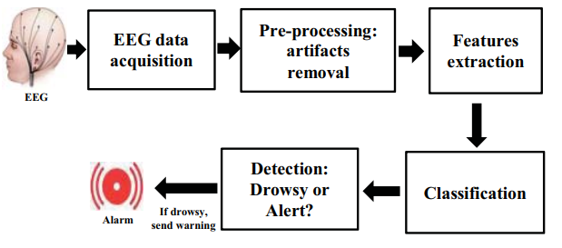

Figure 11: EEG Detection Cycle

Even while EEG is frequently used to improve drowsiness estimation, the raw data collecting method, which includes placing several electrodes on the scalp, is frequently inconvenient and a barrier to real-time onboard applications. These challenges can be overcome by determining the frequency bands and brain regions that are most useful, which will ultimately result in a reduction in the number of electrodes required for data collection. As a result, substantial research is being done in this area to identify the suitable brain regions, electrodes, and frequency bands to develop a universal EEG-based drowsiness detection device that is simple to wear.

As previously established, the delta, theta, alpha, beta, and gamma frequency bands are where the frequency domain behavior of EEG is observed.

Figure 12. shows the waveforms from these frequency bands. Typically, these bands are subjected to PSD analysis, and the absolute and relative power changes between baseline and the drowsy or early drowsy periods are compared.

Each of these five frequency bands has a different range of applications. According to studies, the participants' vigilance and performance states including weariness, drowsiness, and sleep are related to the delta, theta, alpha, and beta bands.

As a result, one of the objectives of ongoing research in this area is to determine the most informative frequency range that can aid in the quicker, more accurate, and more practical real-time use of drowsy state detection.

According to studies, the onset of sleepiness is accompanied by a rise in slow frequencies like delta, theta, and alpha (often in the frontal, parietal, and occipital locations). Faster frequencies, in particular the beta band, demonstrated a decline in activity with the onset of drowsiness in contrast to this. In addition to the frequency bands' absolute and relative power, a number of ratio indices have also been applied.

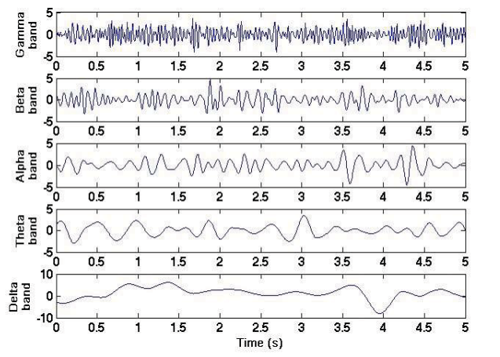

Figure 12: EEG Waves

#### EEG detection

The electrical activity of the brain is captured by an EEG machine. It has electrodes that, when applied to a subject's scalp, can detect brain activity. The EEG machine transfers the data to a computer or cloud server after the electrodes have recorded the brain wave patterns.

Most of these devices have analog to digital converters, amplifiers, filters, and electrodes. While wired EEG equipment must be connected directly to a computer, wireless or portable EEG machines have a battery.

An extended EEG reading is conducted using an ambulatory EEG machine. Ambulatory EEGs record for up to 72 hours, whereas typical EEG examinations record for 1-2 hours, and are frequently used to diagnose sleep abnormalities or seizure disorders.

EEG devices that enable a subject to view their brain activity in real-time are known as EEG neurofeedback machines, also referred to as EEG biofeedback machines. In this kind of EEG monitoring, the subject's brain waves are shown on a computer screen while the EEG machine is synced to a computer or cloud device.

#### Measurement

Instead of capturing ideas or emotions, EEG scanners track variations in the electrical activity the brain generates. Ionic current within and between neurons is what causes these voltage variations. The electrical signals that your brain produces naturally as it takes in and analyses information are what EEG equipment simply catches.

#### Examples of the devices

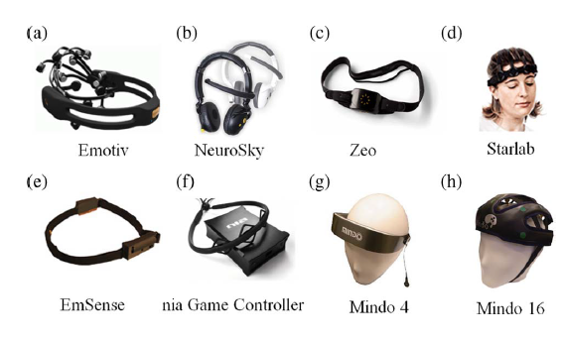

Figure 13: EEG Detection Devices

#### Drawbacks of EEG

Electroencephalogram (EEG) is the most widely accepted signal to assess the driver's state of relaxation. However, because it uses uncomfortable contact electrodes to collect data, this technology is not appropriate as a safety system for common real-life circumstances. Muse 2 is the initial approach to be implemented in the project, but it has a relatively high cost and the idea of wearing a gadget on the scalp will not be the best-suited option since this project is meant to serve different types of drivers, including truck drivers, who drive cars for long periods of time and long distances.

### “Driver Fatigue and Drowsiness Monitoring System with Embedded Electrocardiogram Sensor on Steering Wheel” [5]

The process of electrocardiography involves creating an electrocardiogram, which is a recording of the electrical activity of the heart. It is a heart electrogram, which uses electrodes attached to the skin to create a graph of voltage over time for the electrical activity of the heart. Each cardiac cycle results in the depolarization and repolarization of the cardiac muscle, which is detected by these electrodes. Numerous cardiac disorders, including irregular heartbeat, insufficient coronary artery blood flow, and electrolyte problems, result in changes in the normal ECG pattern.

It is a rapid, risk-free, and painless test as the body is not exposed to any electricity while it is being performed. Like removing a sticking plaster, removing the electrodes from the skin could cause some minor discomfort. Additionally, some people may experience a moderate rash where the electrodes were placed.

Since an electrocardiogram is simple to monitor using a wearable sensor, a drowsiness detection method based on HRV, which is an R-R interval fluctuation obtained from an ECG, has been proposed. Drowsiness has an impact on HRV, which is associated with the autonomic nervous system.

Participants' individual ECG signal patterns may change with time, body posture, and physical circumstances. The P wave, PQ-segment, and QRS complex with strong R-peak, ST-segment, and T waves are represented graphically in Fig. 1 of the ECG wave. It translates the features as time intervals and voltage amplitudes (mV) (msec).

Atrial depolarization results in the production of a P wave, an isoelectric line indicating an AV delay, and what is known as a PQ-segment. Ventricular depolarization results in the generation of the QRS complex, which can occasionally be affected by bundle branch block, a delay, or obstruction of electrical impulses. Additionally, the ST segment is an isoelectric line that accompanies the PQ-segment, and ventricular repolarization results in the generation of the T wave. A higher heart rate is induced by standing and sitting than by sleeping.

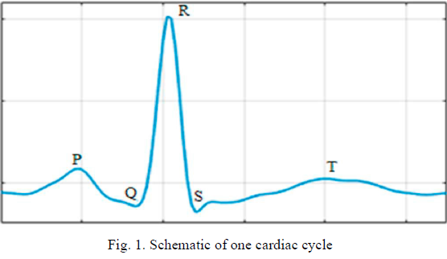

Figure 14: Schematic of One Cardiac Cycle

Standing position, as opposed to sitting and lying down, has been shown to significantly decrease HRV values representing vagal activity and enhance sympathetic activity.

Most HRV measurements, such as SDNN and RMSSD, vary more during rest in the supine position compared to the upright position. Males were also reported to have higher HRV measurements than females.

From supine to standing, there has been observed to be a considerable increase in HR and commensurate drop-in time-domain HRV measurements. At rest, the frequency-domain variables total power (TP), low frequency (LF, ms2), normalized low frequency (LF, nu), high frequency (HF, ms2), and LF/HF measures all show a significant decrease from the supine to the sitting posture and an even greater decrease from the sitting to the standing posture.

The HRV in prone versus supine and prone versus seated postures were both examined in the same study. The study's findings showed that the HR in prone posture remained between supine and sitting posture, and substantial variations were seen in a number of HRV components.

A control system, the autonomic nervous system (ANS) is a component of the peripheral nervous system. It generally operates below the level of consciousness and regulates visceral processes. The parasympathetic nervous system and the sympathetic nervous system are the two traditional divisions of the ANS.

#### Types

**There are three primary ECG types:**

Resting ECG: which is performed when the person comfortably lying down.

Stress or activity ECG: that is performed while on a treadmill or exercise cycle.

Ambulatory ECG: also known as a Holter monitor, connects the electrodes to a small, portable device that is worn around the waist and allows monitoring the heart for one or more days.

#### Drowsiness Detection Using ECG

The embedded ECG sensor interface was put through actual tests, and its performance was assessed. For a 2-hour driving test, two test volunteers (both male, ages 27 and 31), who had no heart conditions, were selected.

A subject was required to drive for two hours nonstop. The subjects were alert and moving around at the beginning, but by the end, the drivers appeared to be quite drowsy, often yawning, and breathing deeply. The time when the individuals experienced feelings of exhaustion and drowsiness while driving was monitored and used to extract three minutes of the recorded ECG signals for condition evaluation.

The test findings for a 27-year-old male person are shown in Fig. The subject's sleepy ECG signals were recorded, and the predicted HRV signals are shown on the first trace. The second trace displays the computed HRV signals as well as the ECG signals for the same subject during a period of weariness. The identical subject's ECG signals are seen in a normal state on the third trace. This study utilized the interpretation of the HRV signals in the time and frequency domains as one of the analysis techniques used to look for the indicator that indicates the activity of the ANS from the collected HRV signals to accurately monitor the subjects' health state. This shows that during tired and sleepy phases, the parasympathetic nervous system was more active than the sympathetic nervous system.

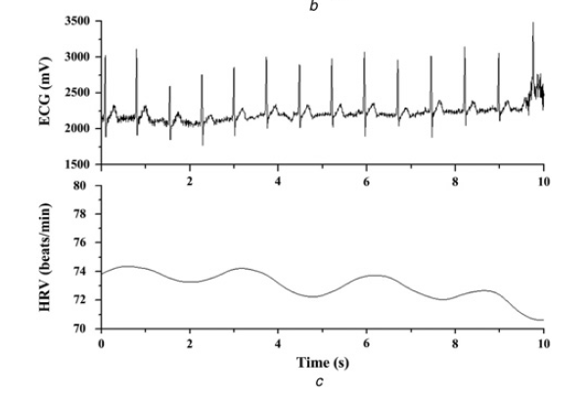

Figure 15: HRV Using ECG for Normal State

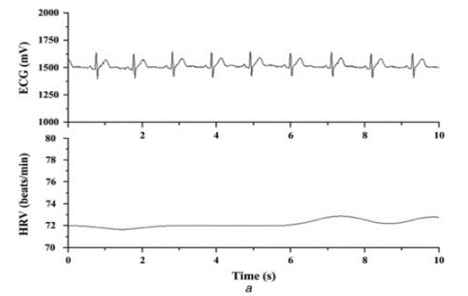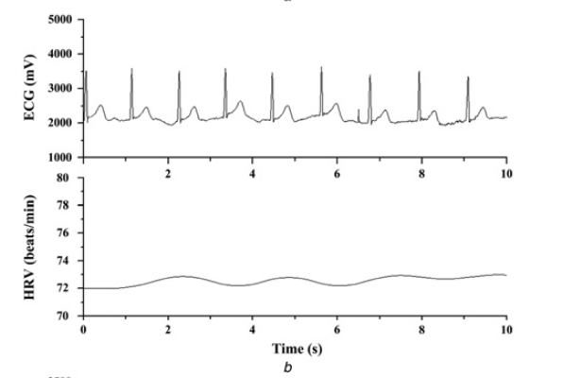

Figure 16: HRV Using ECG for Fatigued and Drowsy State

#### Ad8232 Tests and Drawbacks

For ECG and other physiological measurement applications, the AD8232 ECG sensor shown in Figure 17. is an integrated signal conditioning block. In the presence of noisy circumstances, such as those brought on by motion or the use of distant electrode implantation, it is intended to extract, amplify, and filter minor biopotential signals. An embedded microcontroller or an ultralow power analog-to-digital converter (ADC) may simply acquire the output signal according to this design.

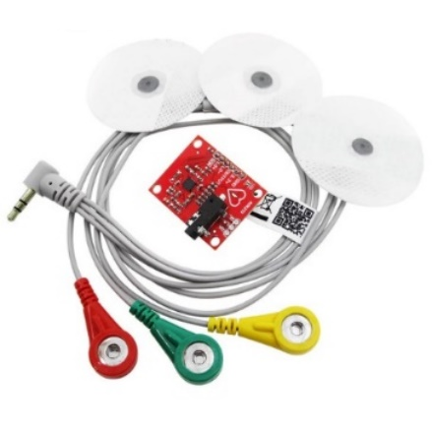

Figure 17: AD8232 ECG Sensor

The purpose of the tests is to compare the BPM values recorded by ECG sensors and devices. The ECG instrument in use is a Philips ECG type G30. By comparing the electrocardiograph sensor output with the results of the equipment, up to 10 tests were conducted. Reading values is done simultaneously. The average error percentage across all 10x experiments was 2.39. The table 7 below shows the results of comparing the BPM readings obtained using the AD8232 ECG sensor and the BPM readings obtained using Philips ECG equipment.

Table 7: BPM Values of AD8232 Sensor

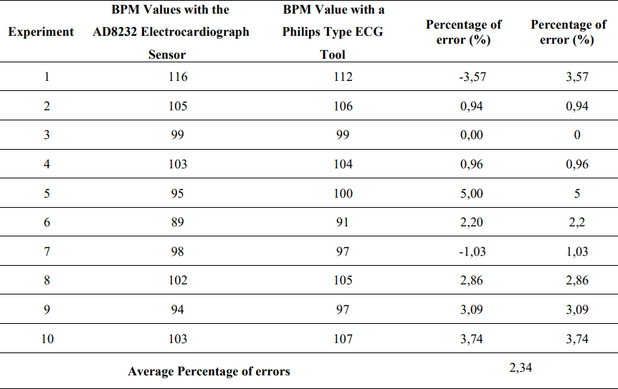

The AD8232 ECG sensor is the most commonly used ECG sensor due to its availability, low cost, and ease of use. Since the ECG sensor is a 3-lead electrode module that requires a placement on the right arm, left arm, and right leg as show in Figure 18. Therefore, the implementation of the sensor is uncomfortable for the driver due to the requirement of attaching the electrodes to the human body's skin.

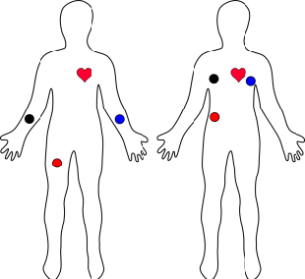

Figure 18: Implementation AD8232 Sensor

#### Capacitive Electrodes Implementation Drawbacks

Capacitive electrodes (CE) enable the collection of biopotentials through a dielectric layer without the need for electrolytes, by placing them on skin or clothing as shown in Figure 19., but they require front ends with extremely high input impedances.

The fully non-contacting ECG capacitive electrodes have been implemented in Ford’s car seat in 2011 as shown in Figure 19. and proved inaccurate results due to vibrations and noises as well as the implementation issues depending on each car seat model. Ford ended the ECG project since the upgradability of the product would not cope with modern life electronics such as wearable bands and smart watches which are low-cost gadgets.

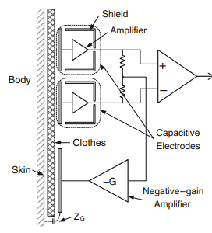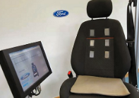

Figure 19: Capacitive Electrodes by Ford

### “A Review on Wearable Photoplethysmography Sensors and Their Potential Future Applications in Health Care” [6]

A simple optical method called photoplethysmography (PPG) is used to determine changes in blood volume in peripheral circulation. It is an inexpensive, non-invasive technique that measures skin surface characteristics.

The method offers insightful data about our cardiovascular system. Interest in this method, which is widely used in clinical physiological testing and monitoring, has been renewed by recent advances in technology and for that reason, it is applied in the project.

#### Principle

Low-intensity infrared (IR) light is used by PPG. When light passes through biological tissues, it is absorbed by venous and arterial blood, skin pigments, and bones. PPG sensors can detect variations in blood flow as changes in light intensity since blood more strongly absorbs light than the surrounding tissues.

The amount of blood flowing through the blood vessels is directly correlated with the voltage signal from PPG. Although this technique cannot be used to measure the amount of blood, it can detect even small variations in blood volume.

A PPG signal has several components, including variations in the volume of venous blood, which modulates the signal, changes in the volume of arterial blood, which are related to cardiac activity, a DC component that displays the optical properties of the tissues, and subtle energy changes in the body.

Place of measurement and contact force between the placement and the sensor are two important variables that influence the recordings from the PPG. Where the variations in blood flow typically happen in the arteries rather than within the veins.

PPG uses a bar or graph to represent the fluctuating blood flow as a waveform. Direct current (DC) and alternating current (AC) components compensate the waveform.

The AC component reflects fluctuations in blood flow that are related to heartbeats. The tissue structure, venous and arterial blood volumes, and optical signals that are reflected or transmitted by the tissues all affect the DC component.

With respiration, the DC component demonstrates minor variations. The DC baseline is stacked on the AC component's fundamental frequency, which fluctuates with heart rate.

#### Usage

PPG technology is used in multiple applications such as:

* Blood oxygen saturation
* Blood pressure
* Heart rate
* Respiration
* Blood pressure and heart rate variability

Focusing on blood pressure and heart rate variability, to detect drowsiness, offer multiple wearable devices with fairly low cost.

#### PPG Signal

Pulsatile (AC) and superimposed (DC) components form the PPG signal. The cardiac synchronous fluctuations in blood volume that result from heartbeats give the AC component. Respiration, sympathetic nervous system activity, and thermoregulation all influence the DC component.  The blood volume fluctuations driven along by heart activity and dependent on the systolic and diastolic phases are represented by the AC component. The pulse wave's systolic peak occurs at the end of the systolic phase, also known as the "rising period," which begins with a valley. Another drop at the conclusion of the diastolic period indicates the completion of the pulse wave. In the bloodstream, vascular changes can be predicted by characteristics including rise time, amplitude, and shape. As demonstrated in Figure 2, PPG can also be used to measure HRV, or fluctuations in peak-to-peak or P-P Interval heartbeat time intervals. The variance may result from a variety of variables, including the person's age, heart health, and level of physical fitness. The PPG signal is split into two distinct phases: the anacrotic (rising edge), which predominantly defines the systole, and the catacrotic (falling edge), which reflects the diastole.

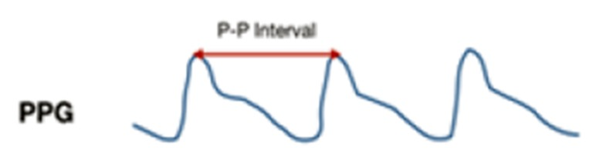

Figure 20: P-P Interval

#### Devices

Since green light is often used to calculate the absorption of oxygen in oxyhemoglobin (oxygenated blood) and deoxyhemoglobin, IR-LEDs are typically utilized to measure the flow of blood that is more deeply concentrated in certain areas of the body, such as the muscles (blood without oxygen present). Although there are alternative LED sensors for measuring hemoglobin that have different colors, green LED is thought to be the most popular. This is simply because it can provide measures that are more accurate due to its deeper tissue penetration. To measure the strength of the light reflected from the tissue, PPG sensors further utilize a photodetector. The amount of the detected light can then be used to determine (measure) the changes in blood volume. Only a few body regions, as seen in Figure 1, are suitable for the placement of wearable PPG sensors.

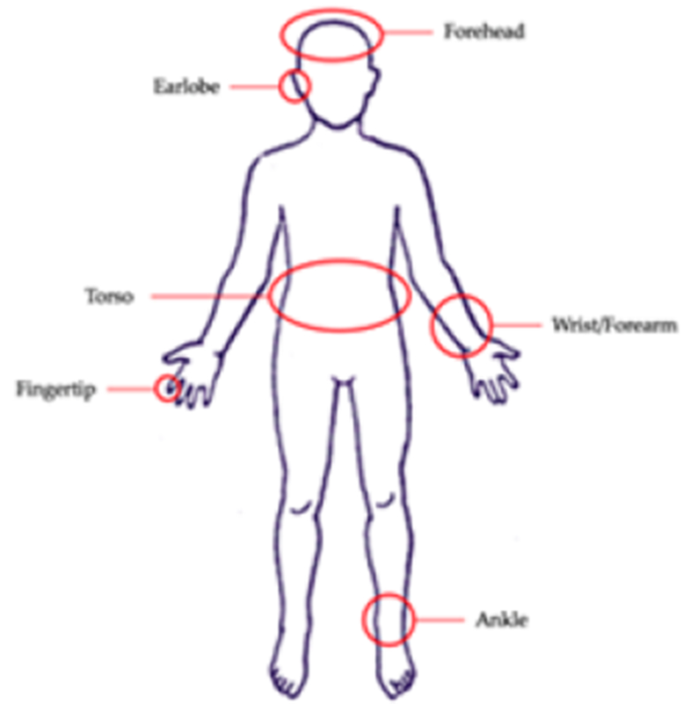

Figure 21: PPG Sensor Implementation Positions on Human Body

However, the degree of precision varies between different measurement sites. Additionally, PPG sensors can be used to identify drowsiness, or an excessive blood flow. Although certain body parts, such the finger, earlobe, and forehead, are frequently used, researchers are also examining at other body parts as more practical options.

PPG sensor-based HR monitoring methods have a number of advantages over conventional ECG-based methods. PPG sensors, for example, require only one sensor to be implanted on the body for functioning and have simpler hardware implementation and cheaper prices. In contrast to conventional ECG recordings. For a traditional ECG-based system to function properly, at least three bioelectrodes must be positioned on various body parts, such as the right arm, left arm, and right leg. This requirement significantly limits the drivers' range of motion. Additionally, PPG sensors can perform better if they are positioned in certain anatomically accessible areas, such as the fingertip and earlobe, where the necessary PPG signals are more successfully captured.

#### PPG Sensors

Although photoplethysmography sensors come in a variety of designs, they all detect changes in blood volume and provide comparable results. A common PPG sensor uses one or more LEDs to emit light at the tissue location. The photodiode monitors the amount of light that is reflected from tissue but is not absorbed. The most common LED colors used in scientific experiments are red and green; however, a yellow LED has also been employed in some investigations. Longer wavelength light can reach deeper into the tissue. As an illustration, infrared light penetrates the skin more deeply than green light. Infrared light, **according to the researchers, is more vulnerable to interference. As a result, for some applications, green LED with a shorter wavelength may be preferable. The movement of the PPG sensor over the tissue, skin deformation, blood flow dynamics, and ambient temperature are the usual causes of interference.**

Whereas the sensor used in the project is the MAX30102 PPG sensor and the future improvement for the existing sensor is the SEN0203 PPG sensor by DFROBOTS since it requires less implementation and comes in with an existing band, but it is currently inaccessible due to the shipping constraints.

#### Wristband-Type PPG-Based Devices

The wristband-type PPG is recognized as the most widely used and desired device among the several PPG-based HR monitoring systems currently available. Its exceptional qualities, such as being affordable, relatively portable, and extremely comfortable for people to wear, contribute to its popularity. These devices do have some restrictions, though as the drawbacks of wrist-type PPG devices for clinical settings have been addressed in several ways, according to several research that have been conducted thus far. The idea of having a wearable device for the driver is acceptable as it can be treated as a wearable band, a seatbelt, or a smart watch to protect his life as well as the pedestrians.

#### Factors Affecting PPG Sensor Recordings

PPG recordings can be impacted by various circumstances. These include biological, sensory, and cardiovascular variables. Alterations of interior tissues, such as muscular movement and tissue expansion, can result from tissue modifications produced by controlled or involuntary motions. These movements will affect the receiving light, resulting in a different signal. The way that light propagates through tissue varies depending on an individual's anatomy, organ size, and the amount of fluid that tissues can hold. The displacement of the sensor is another element that can impact the signal. The sensor may move relative to its initial location as a result of physical activity and body motion. The light's path is affected by the sensor movement, which also modifies the signals. The device's pressure on the skin determines how strong the signal is received. Where this is crucial for the driver as most drivers are exposed to uneven road and continuous vibration.

## Safety Features

### “Detecting Usage of Mobile Phones using Deep Learning Technique.” [7]

In this paper, the authors use deep-learning algorithms, single shot multi-Box detector (SSD) and faster region-based convolution neural network (Faster-RCNN), to detect mobile phone usage. CNNs are the backbone of well-known object detection algorithms.

**Several challenges need to be addressed to achieve a highly accurate and robust framework for detecting mobile phone usage. Some of these are:**

1. CNN models require a massive amount of training data to make robust predictions.
2. Object detection algorithms may struggle to accurately detect mobile phones due to their small size in the image or video.
3. The aim is not only to detect the presence of a mobile phone and a person but also whether the person is using the mobile phone. Simply detecting both objects separately is insufficient since a mobile phone in an image of a person may not necessarily be in use by them.

They have used two datasets. The first dataset is a subset of the State Farm Distracted Driver Detection dataset on Kaggle. This dataset had many irrelevant images, they filtered them manually to create a dataset with a total of 10,238 and call this dataset Kaggle Driver dataset.

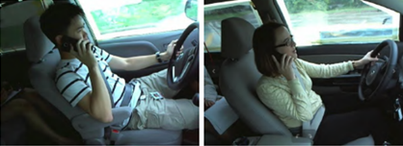

Figure 22: Sample images from Kaggle Driver dataset

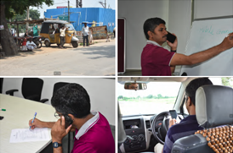

Figure 23: Sample images from IITH-DMU

To enhance the reliability, they developed a new dataset named IITH-dataset on mobile phone usage (IITH-DMU). This dataset contains various images of individuals using mobile phones in diverse backgrounds, these variations help deep-learning models learn more effectively. Currently, IITH-DMU comprises 618 images with a resolution of 6000x4000, and efforts are underway to expand this dataset.

#### Faster-RCNN

Faster-RCNN is more computationally efficient than earlier algorithms in the RCNN family and has lower inference latency. It employs a convolution network called the "Region Proposal Network" (RPN) to generate object proposals or regions.

The RPN uses an input image that is processed by a backbone CNN like Resnet50 or Resnet101. It then places nine "anchor boxes" with various aspect ratios and potential output sizes at each point in the output feature map to assess the likelihood of an object's presence. Finally, the RPN has two parallel units of 1x1 convolution layers, one for object classification and the other for region bounding box regression.

The Faster-RCNN's detector network is trained separately from the RPN. However, the RPN's backbone network shares its weights with the detector network's backbone CNN.

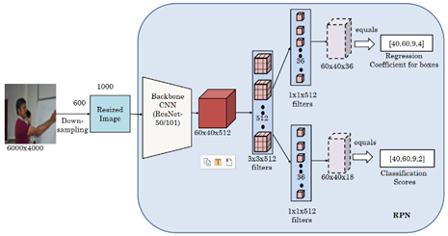

Figure 24: Flow Diagram of RPN

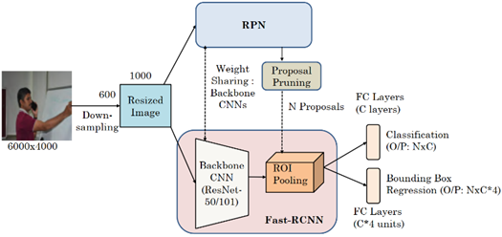

Figure 25: Architecture of Faster-RCNN

#### SSD (Single Shot Detection)

SSD is a popular and efficient method for object detection. They use a single convolutional neural network (CNN) to predict bounding boxes and class labels for objects in an image, making them faster and more efficient than other methods.

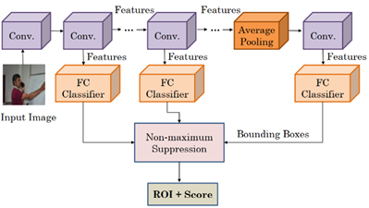

Figure 26: Architecture of SSD

#### FPN (Feature Pyramid Network)

Addressing scale variation in object detection can be time-consuming and memory intensive. One approach is to use feature pyramids, but the feature maps closest to the input image are often too abstract or low-level to accurately detect objects. These pyramids may be used only during inference to improve accuracy, provided inference latency is not a concern.

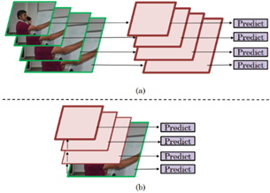

Figure 27: multi-scale object prediction at (a) inference time (pyramid of images) and (b) at training time (pyramid of feature maps) in FPN

FPN is a feature pyramid network that improves on the traditional pyramid concept. It can be used as a substitute for feature extractors in various detectors, including SSD and Faster-RCNN, and produces multi-scale feature maps that are more accurate and faster. FPN consists of a bottom-up and top-down pathway, as shown in Figure 7. The bottom-up path is a regular CNN, while the top-down pathway creates a high-resolution layer from a semantically rich layer. This allows for better resolution and semantic value as we move up the layers.

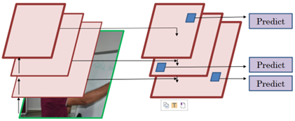

Figure 28: Architecture of FPN with bottom-up and top-down pathways

#### Datasets

They create a custom dataset that is more generic and has pictures with a higher amount of variation. This dataset called as a “IITH-dataset on mobile phone usage” (IITH-DMU) has a total of 618 images, out of which they used 338 for training and 280 for testing purposes. This dataset has images of people from office, village, market or street setting, it has also pictured of both small/old and new/large phones.

The IITH-DMU dataset has a high resolution of 6000x4000, which allows for fewer images to be used in training the CNN model. The dataset is currently being expanded, and there are plans to release it to the public. Table 1 provides a summary of the dataset's properties.

Table 8: Characteristics of datasets

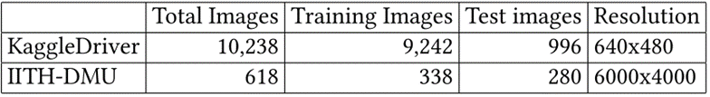

#### Choice of Object Detection Algorithms

Choosing the right deep-learning model is crucial for achieving high predictive performance while balancing model size and latency. Table 2 displays the map scores of several state-of-the-art models on the COCO dataset, with Faster-RCNN and SSD models. showing strong scores for object detection. This is why the authors have chosen to use these models.

Table 9: Results on COCO

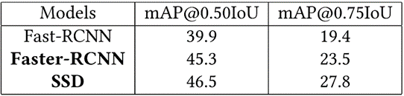

#### Annotation Approach

To perform object detection, the authors used the Labeling tool to label images in their datasets. They aimed to detect not just the presence of a mobile phone and person, but also whether the person is using the mobile phone. They evaluated three annotation approaches: (1) annotating only the mobile phone, (2) annotating mobile phone and hands separately and finding the intersection, and (3) using a "compound" annotation approach where the hand and mobile phone are annotated together in a single bounding box. They found that the compound annotation approach was the most effective, as it had higher result accuracy and was less time-consuming than the second approach.

#### Results and Analysis

The authors evaluated four deep learning models for object detection: Faster-RCNN with ResNet50 backbone, Faster-RCNN with ResNet101 backbone, SSD with Inception_v2 backbone, and SSD with ResNet50 backbone that implemented FPN. The reason for implementing SSD with FPN is to detect objects in images with different scales, as shown in Figures 1 and 2. Processing multi-scale objects requires high memory resources and training time, so FPN was used as a feature extractor to achieve high accuracy and speed.

Table 10: Results on two datasets

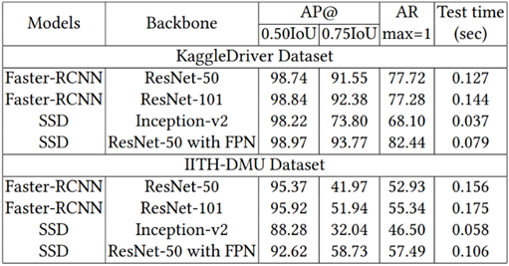

Table 10 displays the object-detection results on different datasets using different deep learning models, with AR (average recall) and IOU (intersection over union). The results indicate that SSD models are faster than Faster-RCNN models in all cases, making them preferable for latency-critical situations. While SSD with Inception-v2 backbone achieves the lowest latency, SSD with ResNet50 as the backbone and FPN as the feature extractor is a good balance of accuracy and speed. It also shows that using ResNet-101 as the backbone for Faster-RCNN provides a slightly higher AP score than using ResNet-50. For SSD, using "ResNet-50 with FPN" results in slightly lower AP than Inception-v2 for 0.5IOU, but significantly better AP for 0.75IOU. It is important to note that 0.75IOU is a stricter metric than 0.5IOU. Comparing Faster-RCNN and SSD, Faster-RCNN gives higher AP at 0.5IOU, while SSD with "ResNet-50 with FPN" backbone gives the highest AP at 0.75IOU. In summary, SSD provides a better tradeoff between accuracy and speed than Faster-RCNN.

On the IITH-DMU dataset, Faster-RCNN provides significantly better AP than SSD at 0.5IOU, while SSD with ResNet-50 and FPN provides higher AP than Faster-RCNN with ResNet101 backbone at 0.75IOU. Precision was computed as TP/(TP+FP), with Faster-RCNN having both high TP and FP, while SSD (with FPN) had fewer TP and FP. This could be due to FPN creating a relationship between each scale of the feature pyramid to prevent unnecessary detections and efficiently increasing the number of feature maps of each layer in the feature pyramid, resulting in higher efficacy.

#### Analysis of Failure Cases

The authors focused on analyzing the performance of Faster-RCNN with ResNet-101 and SSD with ResNet-50 and FPN. Figure 9 shows some test images from the IITH-DMU dataset that the models failed to correctly predict. One common reason for this failure is the lack of training data for exceptional cases.

The reasons for specific failures are as follows: (a) eyeglasses were erroneously detected as a mobile phone, (b) a marker was interpreted as a slim mobile phone, (c) the person's palm was folded similar to the posture of holding a mobile phone, (d) the Faster-RCNN model mis predicted that the person was using the mobile phone, and (e-f) the mobile phone appeared too small for the SSD model to detect, resulting in false negatives.

The authors believe that addressing these deficiencies can be achieved by enhancing the dataset with more images and fine-tuning the deep-learning models, which is part of their ongoing research.

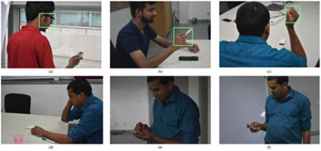

Figure 29: Failure cases

(As shown in Figure 29) Some of the incorrect predictions. (a)-(c) are mis-predicted by both the models. (d) is mis-predicted only by Faster-RCN and (e)-(f) are mis-predicted only by SSD.

To conclude the authors presented a challenging dataset of images depicting mobile phone usage and used deep-learning algorithms to detect mobile phone usage, achieving high accuracy on both datasets. They plan to include stereo camera images and perform depth-estimation in the future, as well as use plugins to improve the accuracy of the SSD model for small objects. They aim to evaluate their technique on low-resource platforms such as CPUs to expand its applicability in various scenarios.

### “Simultaneous Face Detection and Pose Estimation Using Convolutional Neural Network Cascade”

In this paper, face detection and pose estimation combined by Multi-task CNN cascade framework to achieve real-time performance.

The proposed method

The proposed is a multi-task framework for real-time face detection and pose estimation using cascaded networks, multi-task learning, and feature fusion to improve CNN architecture.

#### Overall Framework

The multi-task framework consists of three CNN components: Coarse-detection Network, Optimized-detection Network and Fine-detection & Pose-estimation Network. Coarse-detection Network classifies probability, Optimized-detection Network rejects false detections, and Fine-detection & Pose-estimation Network estimates pose for each detected face.

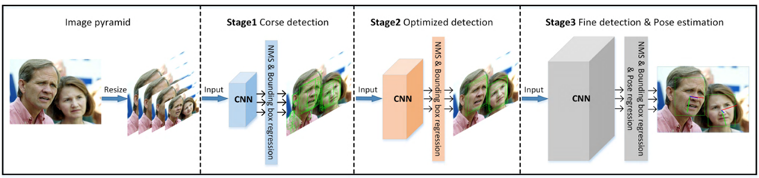

Figure 30: The CNN framework

The framework consists of three cascaded deep convolutional neural networks, optimizing the face detections of the front CNN and performing pose estimation on fine face detections.

#### CNN Architectures

1. **Inspiration and considerations**

Cascaded convolutional neural networks have achieved reliable performance in face detection, with three networks adjusting the input image size to 10*10, 20*20, 40*40. The network width and depth are determined based on the classification effect of the model to the dataset.

1. **Coarse-detection network**

The Coarse-detection Network is a shallow fully convolutional network used to quickly find regions that contain exactly one face on the images. It has an input size of 10 * 10 and gives a face vs. non-face classification probability distribution, bounding box regression offsets, and pose regression vectors for each window. In the training stage, the three variables are used as optimization targets.

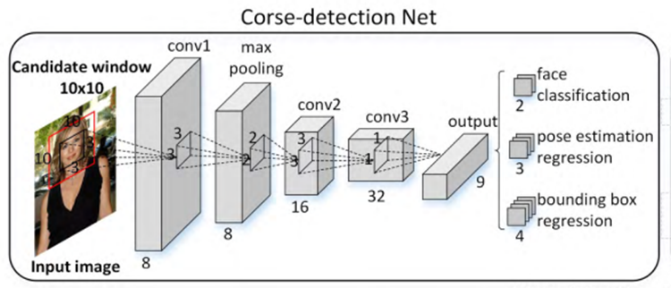

Figure 31: Corse-detection Net

1. **Optimized detection network**

The Optimized-detection Network is a CNN after Coarse detection Network that rejects false detection windows. The final layer outputs a vector containing face vs. non-face binary classification score, bounding box regression offsets, and pose regression vector.

1. **Fine-detection & pose-estimation network**

The Fine-detection & Pose-estimation Network is the last CNN in the framework. It has fine detection windows and more accurate pose estimation due to its more complicated network structure.

#### CNN Feature Fusion Strat

CNN features are hierarchically distributed, with lower layers containing better localization properties and deeper layers containing more complicated features. Our baseline framework only takes advantage of the complex features of deeper layers, so we reconstruct a new CNN by fusing the low, mid, and high-level layers of the last

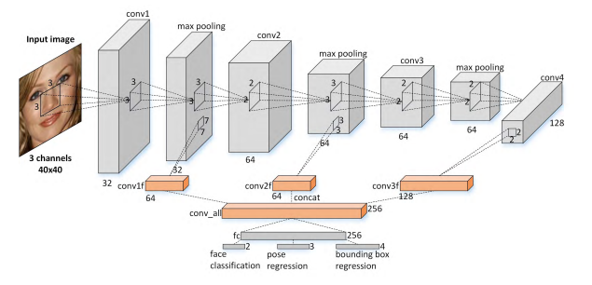

Figure 32: The architecture of improved CNN

#### Experiment result

1. **Face detection results**

Comparing the face detection result against state-of-the-art methods on the Face Detection Data Set and Benchmark (FDDB) dataset, this method outperforms most of the reported algorithms. Qualitative evaluation results show it can deal with challenging cases. Comparisons of face detection with state-of-the-art methods on (a) ROC curves on FDDB with discrete scores, (b) ROC curves on FDDB with continuous scores (shown in Figure25)

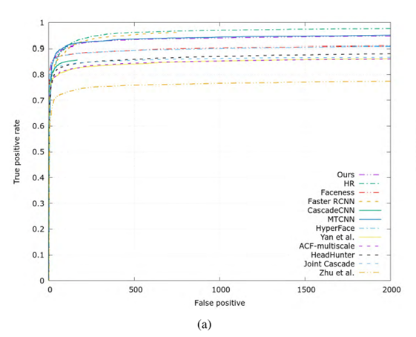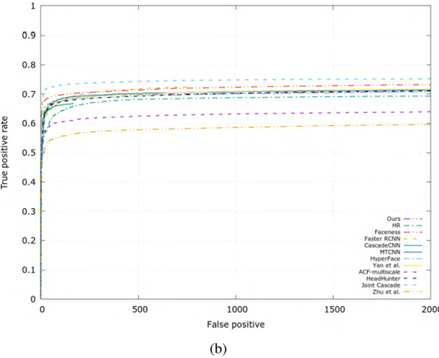

Figure 33: Comparisons of face detection

1. **Pose estimation results**

Annotated Faces in the Wild (AFW) is a popular dataset used for the evaluation of face alignment algorithms. It consists of 205 images collected from Flickr containing 468 in-the-wild faces with absolute yaw degrees up to 90. This paper presents the pose estimation performance on the AFW dataset. The method outperforms the first four methods by a large margin and is comparable with state-of-the-art methods using deep learning. However, Hyperface takes 3s to process an image and All-in-One takes 3.5s per image. The AFW processes 30 entire images per second and the speed is extremely competitive compared with other methods. Pose Estimation cumulative error distribution curves on AFW dataset. The numbers in the legend are the percentage of test faces with absolute yaw error less than or equal to 15 Degree (shown in Figure 26).

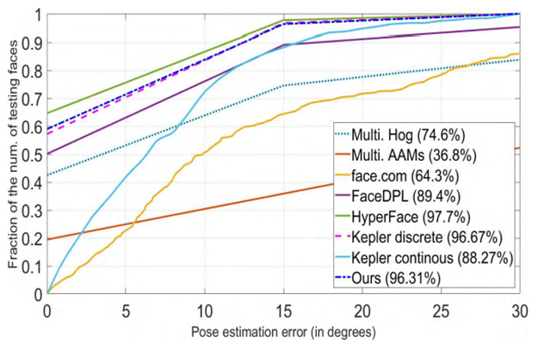

Figure 34: Pose Estimation cumulative error

1. **Ablation experiments**

Additional experiments to explore the correlation between CNN feature fusion and ablation studies to gain deeper insights.

1. **Joint training of face detection and pose estimation.**

Joint training of face detection and pose estimation promotes the performance of face detection on FDDB dataset, as evidenced by the performance of two frameworks.

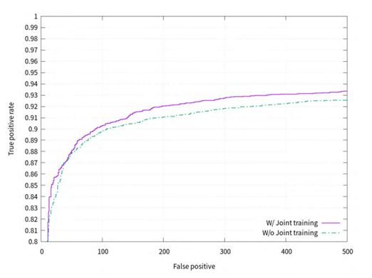

Figure 35: Comparisons of ROC curves on FDDB with and without joint training

1. **CNN feature fusion**

The Fine-detection & Pose-estimation Network was reconstructed by fusing the low, mid, and high-level layers of the last CNN.

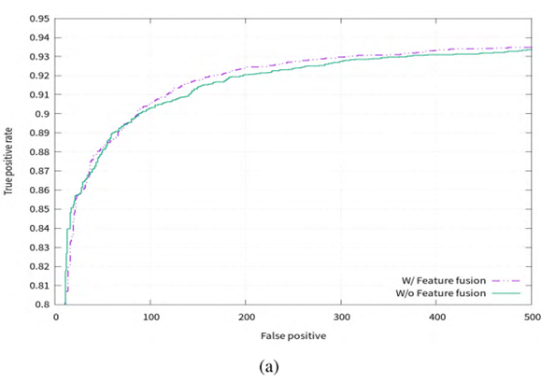

Figure 36: Comparisons of ROC curves on FDDB with and without feature fusion

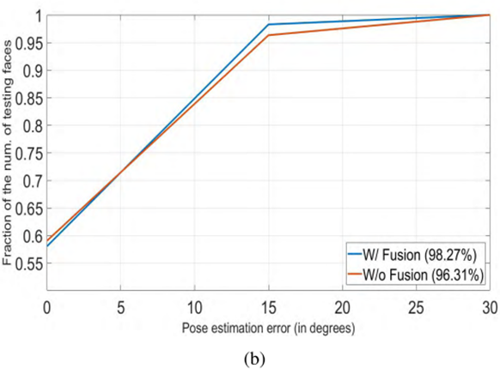

Figure 37: Cumulative error distribution curves on AFW with and without feature fusion

The face detection tasks do not gain much by fusing intermediate layers but pose estimation task achieves a boosted performance (shown in Figure 28 & Figure 29) due to the hidden information from lower layers.

1. **Runtime efficiency**

Cascade-based methods have the advantage of runtime efficiency, combining several simple CNNs for faster face detection and better accuracy. The method achieved about 30fps for the two tasks. Compared with the methods for resolving multiple face-related tasks, this method is quite fast in computation speed. Hyperface takes 3s per image on a GTX Titan X GPU and All-in-one takes an average of 3.5s to process an image. Compared with these methods, this method achieves real-time performance for simultaneous face detection and pose estimation.

#### Conclusion

The "Simultaneous Face Detection and Pose Estimation Using Convolutional Neural Network Cascade" paper offers a highly effective method for simultaneously detecting faces and estimating their poses. However, it has some limitations, such as the need for a lot of labeled training data and high computational resources. Additionally, the method may not be robust to occlusion, meaning that if a part of the face is obscured by an object or another part of the face, the method may fail to detect or estimate its pose accurately.

### “Drowsy Driver Detection via Steering Wheel”

#### Steering Wheel Drowsiness Detection

These days, numerous technological innovations have been included in automobiles to improve their safety systems, such as the automatic brake system (ABS), airbags, distance sensors, fingerprint technology to start the car, and safety belts for the front and rear passengers. Due to the increase in incidents reported by the National Highway Traffic Safety Administration year after year, all of this equipment was created to prevent accidents.

In order to ensure that the driver is operating their vehicle in a reasonable condition while they are feeling sleepy, sensors should be fitted around the steering wheel to monitor how well their hands are gripping it. For a typical driver, the calibration of hand force should be performed. The vibration system and sound system will be engaged to alert the driver of tiredness if the force acting on the steering is outside of the calibration range.

#### System Concept

The transmitter module circuit and receiver module circuit form the foundation of the system. The second module, known as the receiver module circuit, includes the main brain that processes all of the data that is received from the sensors for this study. This brain then has to communicate the data processing to the receiver module circuit, which is depicted in Fig. 1. In general, this second module uses wireless connection to trigger the motor vibrator inside the driver's seat. HotPot membrane potentiometer sensors and Rotary potentiometers are the two types of sensors that will be used in this project. When the gas pedal is depressed, a hotpot membrane potentiometer will measure the force applied to the steering wheel, and a rotary potentiometer will measure the vehicle's speed.

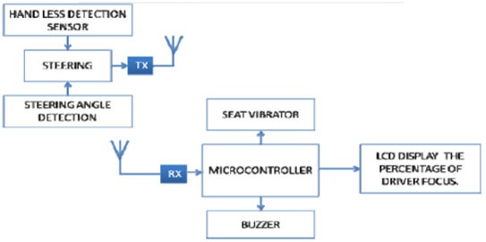

Figure 38:

#### Hardware Used

• HotPot Membrane Potentiometer: As shown in Fig. 2, the HotPot Membrane Potentiometer serves as a force-sensing resistor in an electrical circuit.

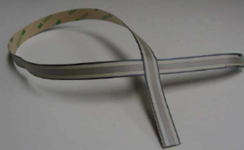

Figure 39: HotPot Membrane Potentiometer

• Transmitter Radio Frequency Module: These RF Transmitter Modules, which are relatively compact in size and have a wide operating voltage range (3 V–12 V), are shown in Fig. 3. The low-cost RF transmitter can be used to transmit signals up to 100 meters because the antenna design, working conditions, and supply voltage greatly influences the effective range. It is beneficial for the development of battery-powered, short-range devices.

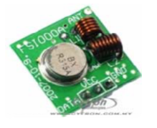

Figure 40: RF Transmitter Module

• Receiver Radio Frequency Module: These RF receiver modules, as shown in Fig. 4, are extremely compact. The low-cost RF receiver can be used to pick up an RF signal from a transmitter at a particular frequency that is specified in the product specifications. Strong signal sensitivity is ensured by super regeneration design.

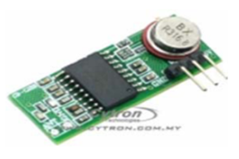

• Liquid Crystal Display (LCD) and Potentiometer as shown in Fig. 5

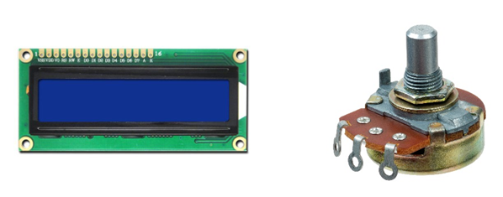

Figure 41: LCD & Potentiometer

• Microchip PIC18F452 Microcontroller: A microcontroller as shown in Fig. 7 is a compact computer on a single integrated circuit that combines a relatively simple CPU with support features including a watchdog timer, serial and analog I/O, a crystal oscillator, and timers. Along with a relatively tiny amount of RAM, chips frequently feature program memory in the form of NOR flash or OTP ROM. Microcontrollers are made for specific, specific uses.

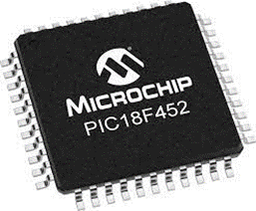

Figure 42:

#### Installation of Hardware

The amount of holding pressure applied by the driver's hand will be detected by the HotPot membrane Potentiometer, which is mounted at the steering wheel, as depicted in Figure 43.

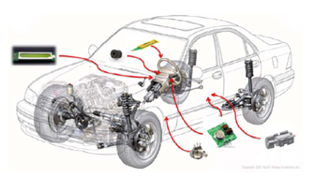

Figure 43:

This sensor will draw its current source, which is equal to 5 V, from the automobile battery using a converter. The fuel pedal's installed potentiometer will measure the angle it moves at. The dashboard's LCD panel makes it simple for the driver to monitor while driving. To function well and produce a loud sound when engaged, a high-frequency buzzer is installed on the dashboard and opens air close to the driver's position. When the driver becomes fatigued or sleepy while driving, the two motor vibrators installed inside the driver's seat will cause both driver’s thighs to vibrate. As well as mounting the HotPot membrane potentiometer as shown in Figure 44.

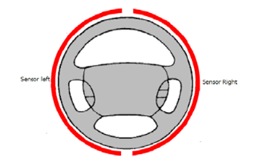

Figure 44;

The entire outside surface of the steering wheel was covered by two sections of this sensor. The driver's seat is equipped with two motor vibrators, and the activation requires a 12 V DC power supply. Two motor vibrators are mounted, as indicated by the two red circles in Fig. 10. When a driver is in motion, the motor vibrator must be positioned so that it is parallel to the driver's thigh. When a driver starts to sleep, both thighs will vibrate.

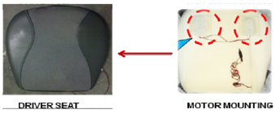

Figure 45:

#### Main System

The primary system is normally supplied by four input sensors, as shown in the block design in Figure.46. The input sensors consist of two HotPot membrane potentiometers, a gasoline pedal potentiometer, and a push button that acts as a calibration button. Around the whole external steering surface was a membrane potentiometer developed by Two Hotpot. Each of these sensors covered half of the steering surface. The output terminal of the sensor will travel via the amplifier circuit to amplify the lower signal produced by this sensor when specific hand pressures are applied to the steering. After being amplified, the output signal was connected to the PIC18F452 microcontroller's analogue input.

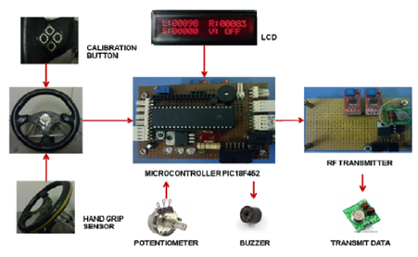

Figure 46:

All the car's systems will automatically activate after the engine has started, and then the system will ask the driver to perform a hand calibration by pushing the button next to the steering wheel on the left.

This module has three outputs: a buzzer, an LED, and an encoder for wireless transmission. The high-frequency buzzer was utilized in this project because it can distract a driver who gets sleepy or fatigued while driving and lead them to lose focus. The drivers will therefore pay close attention while driving to avoid this buzzer activating. This technology uses bright LEDs to dazzlingly light up the driver's eyes, blocking their vision. Before transmitting the data wirelessly to the second module, the chip PT2262 encrypts the data.

#### Slave System

Four essential components make up the slave system, as seen in Figure 47. The four essential components are the RF receiver module, chip PT2272, relay, and vibration system. The data was collected from the transmitter module installed in the main system via the RF reception module and then transferred to the PT2272 decoder chip. Now that the data had been decrypted, it was possible to determine whether the motor vibrator had been activated. The decoder chip PT2272, which was coupled to the relay and operated by a transistor, then acknowledged the information. When it senses 5 volts at the base terminal, this transistor acts as an internal switch to activate the relay's coil.

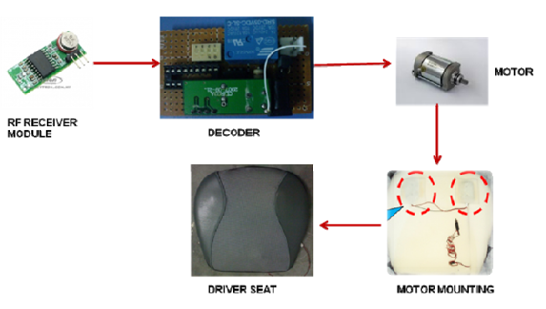

Figure 47:

Additionally, the slave system offered a security code system that could only accept signals from the primary system. If this security code system is not in place, the unexpected signal may have an impact on the data that the RF receiver module receives. The user can set the 4-digit combination of the password for the protection aspect using the DIP switch attached to the chip PT2272.

#### Results and Data Analysis

Once the car's engine is running, the system will synchronously activate, and the LCD will then show as in Fig. 13. Indicating that the car is not moving and that no force is being given to the steering wheel, the gas pedal, right-hand grip, and left-hand grip are all now set to zero. The sound and vibration system are thus not activated by the systems. Be aware that the system won't start the warning if there aren't any hand pressures on the steering wheels while you're driving.

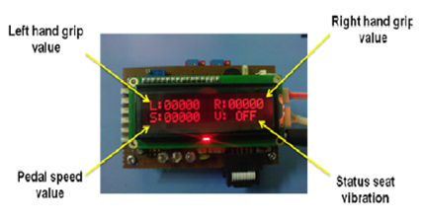

Figure 48:

The hand forces acting on the steering wheel have been analyzed. Fig. 14 shows the value that the LCD displays when the driver's left hand is either lightly or firmly placed on the steering wheel. The PIC18F452 microcontroller will transform the amplifier's analog value into a digital value for study. The LCD panel will then show the value of the hand forces. The same circumstances that are depicted in Fig. 15 apply to the right-hand forces.

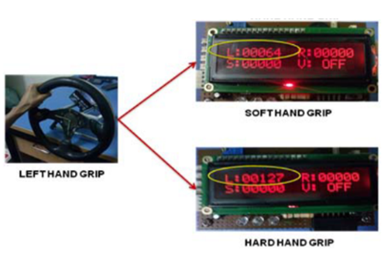

Figure 49:

Some of the cases should be tested to see if the system works as intended. When the vehicle is stationary, but the engine is still running, the system must be constantly vibrating and turning on the sound system. The technology only activates the seat vibration and sound system when the car is moving and the driver releases or re-secures their grip on the steering wheel. While the driver is operating the vehicle with just one hand, the warning system does not activate.

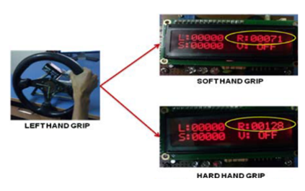

Figure 50:

* Case 1: The vehicle's engine is still running, but it is travelling very slowly and lacks hand grips on the steering wheel. Therefore, assuming that this won't result in the warning system going off. When the engine is warming up and the vehicle is stopped, this condition occurs.
* Case 2: The car is still moving, yet it is standing still, and the hand grips on the steering wheel are in motion. Therefore, assuming that this won't result in the warning system going off. This happens while the driver is grasping the steering wheel and the car is halted at a stop sign.
* Case 3: While the automobile is moving, the driver is holding the steering wheel with normal grips that are within the calibration range. believing that the warning system won't trigger in this situation as a result. This scenario happens if the drivers routinely operate the car.
* Case 4: The driver is holding the wheel while the car is moving, but the hand grip is not calibrated. As a result, anticipate that the warning system will activate in this instance. If the drivers become sleepy or fatigued while driving, this situation occurs.

This Experiment cannot be carried out to our current project because of the lack of facilities and components.

# System Component Candidates

## Computer Vision drowsiness detection

### Eye Aspect Ratio (EAR)

The aspect ratio describes the relationship of an object's width to its height. The Eye Aspect Ratio is an estimate of the eye state. Each eye is represented by 6 (x,v) –coordinates (shown in Figure 23), Calculates the ratio of distances of the sum of the difference between the vertical points to twice the difference between the horizontal points. EAR is always calculated for the left and right eye separately.

$$EAR=\frac{\left|P_{2}-P_{6}\right|+|P_{3}-P_{5}|}{2\left|P_{1}-P_{4}\right|}$$

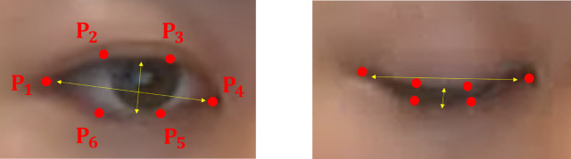

Figure 51: EAR

### Methodology

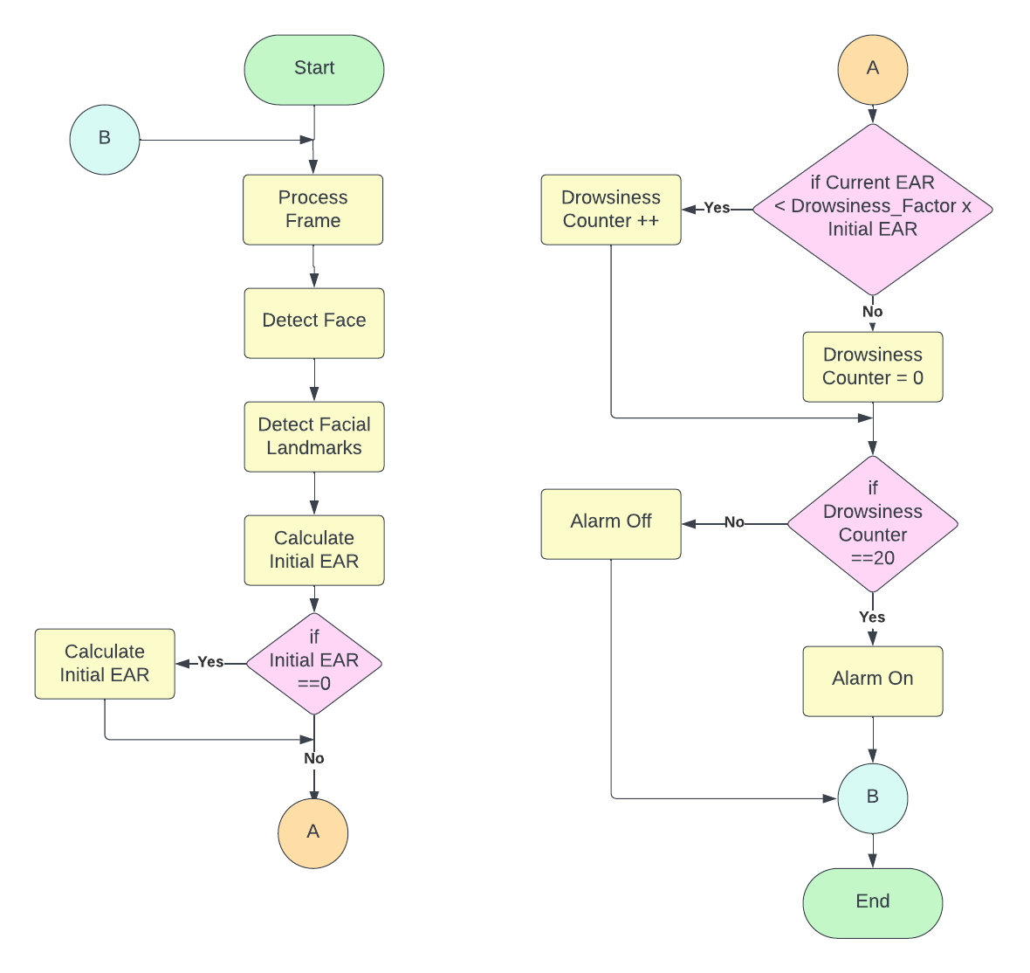

Figure 52: Flow Chart

### Dlib Face Detection

After processing the image such that the face area is completely visible, dlib’s face detector is used to find and locate the face in the image. The dlib face detector is pretrained model using HOG algorithm.

### Dlib Facial Landmarks

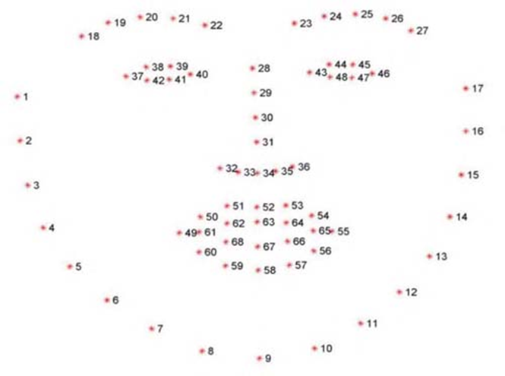

Figure 53: Landmarks Coordinates

Facial landmark recognition is used to detect drowsiness and fatigue. To detect sixty-eight facial landmarks, we used the open-source Python library d-lib. These predefined annotations help in shape prediction by recognizing various facial regions such as the eyebrows, eye, nose, and mouth region, among others (shown in Figure 22).

Table 11: Coordinates of various facial regions

|  |  |
| --- | --- |
| Region | Coordinates |
| Jaw | [0 - 17] |
| Right eyebrow | [18 - 22] |
| Left eyebrow | [23 - 27] |
| Nose | [28 -36] |
| Right eye | [37-42] |
| Left eye | [43 - 48] |
| Mouth | [49 – 68] |

### Dlib Pre-processing

To capture the video, we used a wide-angle color camera attached to the car’s dashboard at an angle that can see the driver’s face. The video stream that acquired by the camera is converted into frames so that it is easy to process and detect objects. Then the system converts each frame from BGR to grayscale for easier processing.

### Data gathering

After processing the image, dlib’s face detector is used to find and locate the face in the image. The pre-trained facial landmark detector in the dlib library is used to estimate the position of 68 (x, y)-coordinates (as shown in Fig. 1) that map to facial structures on the face to locate the facial landmarks. Following the location of the coordinates, the system establishes a bounding box around the face to concentrate properly.

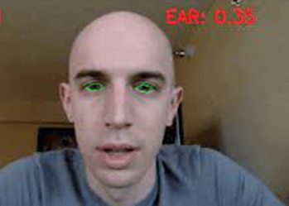Going ahead, we extract the coordinates of both eyes, and encapsulate the focused region into a polygon. We then draw contours around the eyes region by joining the coordinates along the boundary for visual shape analysis by green boundary (shown in Figure33).

Subsequently, we calculated the initial Eye Aspect Ratio (EAR) of the driver as soon as the system is turned on, that is when the car is started, and a face is detected. We do so because using a single standard EAR threshold value can result in inaccurate predictions for people with certain genetic disorders or people of various nationalities.

Figure 54: The Eye Region

### Dlib Results

Our system is extremely sensitive; therefore, we must consider two major factors: first, the accuracy of the system in detecting drowsiness, and second, the speed of our system in calculating the frequency of the code.

Table 12: Dlib Accuracy Results

|  |  |  |  |  |  |  |  |  |  |
| --- | --- | --- | --- | --- | --- | --- | --- | --- | --- |
| persons | Glasses | Frames | Negative (Awake) | Positive (Drowsy) | TN | TP | FN | FP | Accuracy |
| 1 | No |  |  |  |  |  |  |  |  |
| 2 | No | 239 | 161 | 78 | 160 | 73 | 1 | 5 | 97.45% |
| 3 | Yes | 79 | 53 | 26 | 53 | 26 | 0 | 0 | 100% |
| 4 | Yes | 228 | 108 | 120 | 108 | 119 | 0 | 2 | 99.12% |
| 5 | Yes | 99 | 50 | 49 | 49 | 49 | 1 | 0 | 98.99% |
| Average Accuracy | | | | | | | | | **98.89%** |

As shown in table # the accuracy is 98.89% which is the highest accuracy but on the other hand the frequency is 8– 10 Frame per second, using Jetson nano, that decreases the response of the system, as we need more than 20–frame to detect the driver drowsiness.

### Dlib Custom Eye Predictor Results

In order to improve the speed of the code, we use a pretrained custom model for the 12 landmarks of the eyes only instead of all 68 landmarks. The pretrained custom model is trained using the iBUG 300-W dataset.

Table 13: Dlib Custom Eye Predictor Accuracy Results

|  |  |  |  |  |  |  |  |  |  |
| --- | --- | --- | --- | --- | --- | --- | --- | --- | --- |
| Persons | Glasses | Frames | Negative (Awake) | Positive (Drowsy) | TN | TP | FN | FP | Accuracy |
| 1 | No |  |  |  |  |  |  |  |  |
| 2 | No | 149 | 70 | 79 | 70 | 63 | 0 | 16 | 89.29% |
| 3 | Yes | 186 | 102 | 84 | 100 | 84 | 2 | 0 | 98.92% |
| 4 | Yes | 264 | 147 | 117 | 142 | 115 | 5 | 2 | 97.35% |
| 5 | Yes | 88 | 34 | 54 | 34 | 54 | 0 | 0 | 100% |
| Average Accuracy | | | | | | | | | **96.38%** |

The enormous number of photos in the dataset caused the custom dlib model to perform less accurately than the official model, as shown in table #. Additionally, the speed did not vary as much as we had anticipated, staying between 9 and 11 frames per second using jetson nano.

During the accuracy test, the custom dlib eye detector model was unable to accurately identify the eye in some frames, as shown in Figure 55. The driver may experience a false awake state as a result of the system's incorrect closed eye detection.

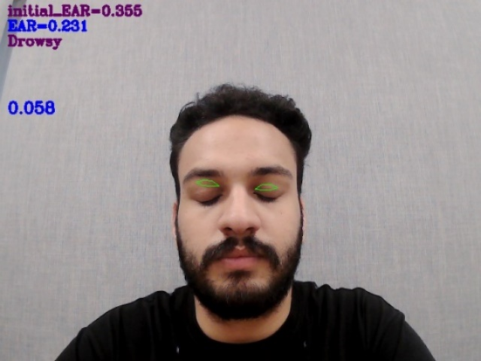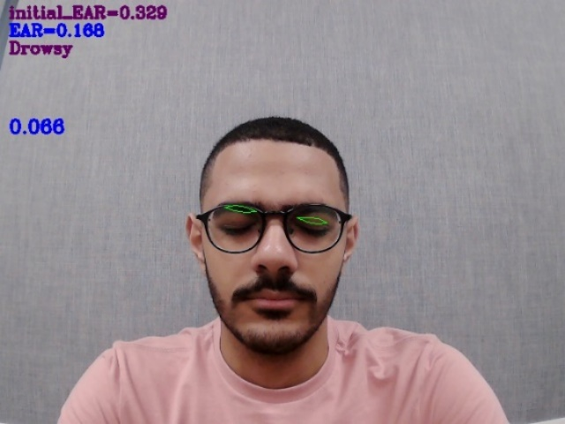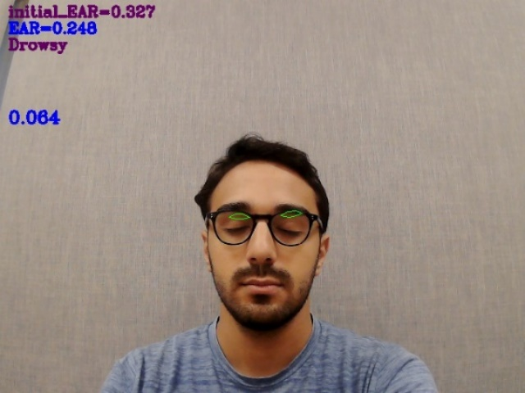

Figure 55: Custom Dlib Eye Predictor Failures

### MediaPipe Landmarks

The MediaPipe Face Landmark lets you detect face landmarks and facial expressions in images and videos. You can use this task to identify human facial expressions by detecting 478–landmark. The indices of the landmarks are not arranged as shown in Figure 56. We use the same technique as we did in Dlib Landmarks, all we need is the EAR for each eye.

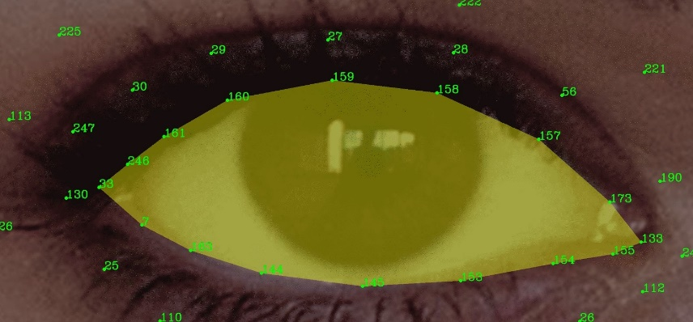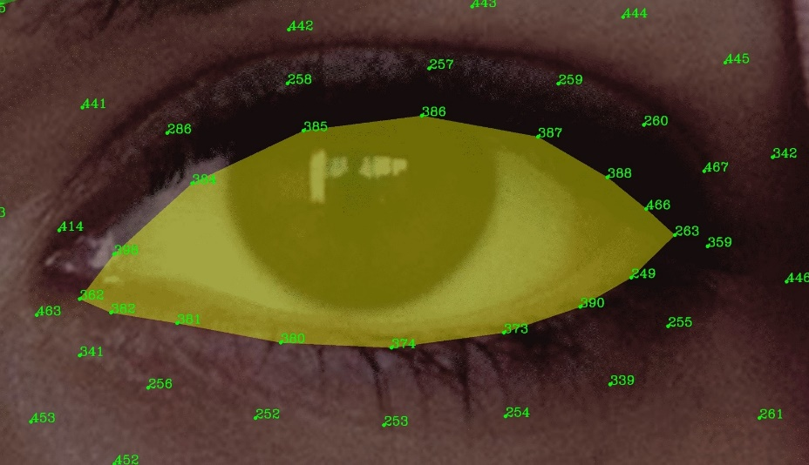

Figure 56: MediaPipe Eye Landmarks

Only the right and left eyes serve as landmarks, thus we begin counting from the left side of the eye and count anticlockwise to arrange the indices as given in table 14.

Table 14: MediaPipe Eye Landmarks Indices

|  |  |
| --- | --- |
| Landmark | Indices |
| Right Eye | 33, 7, 163, 144, 145, 153, 154, 155, 133, 173, 157, 158, 159, 160, 161, 246 |
| Left Eye | 362, 382, 381, 380, 374, 373, 390, 249, 263, 466, 388, 387, 386, 385, 384, 398 |

### MediaPipe Results

Table 15: MediaPipe Accuracy Results

|  |  |  |  |  |  |  |  |  |  |
| --- | --- | --- | --- | --- | --- | --- | --- | --- | --- |
| Persons | Glasses | Total Frames | Negative (Awake) | Positive (Drowsy) | TN | TP | FN | FP | Accuracy |
| 1 | No |  |  |  |  |  |  |  |  |
| 2 | No | 306 | 168 | 138 | 168 | 137 | 0 | 1 | 99.67% |
| 3 | Yes | 358 | 172 | 186 | 171 | 181 | 1 | 5 | 98.24% |
| 4 | Yes | 458 | 230 | 228 | 230 | 199 | 0 | 29 | 93.67% |
| 5 | Yes | 187 | 157 | 130 | 128 | 155 | 2 | 2 | 98.61% |
| Average Accuracy | | | | | | | | | **97.55%** |

## ECG

### Circuitry

As part of the research on analog signal amplification and filtration, circuit concepts were chosen Jeremy Nash, who has experience designing and building circuits, suggested using a Sallen-Key filter to isolate the target frequencies. The decision to use two Sallen-Key filters in series (a Butterworth filter) to sharpen the amplitude attenuation after the corner frequency resulted from sound filtration research. The preamplifier circuit was found online and chosen because it was designed to be used with a condenser microphone, similar to the one chosen for the fetal heart monitor.

The condenser microphone signal is routed through a pre-amplifier, a low pass Butterworth filter, and then to the Arduino for digital analysis. The Arduino's 5V DC power supply will power the entire circuit. The circuit will be built on a breadboard. The circuitry is depicted in Figure 26 below.

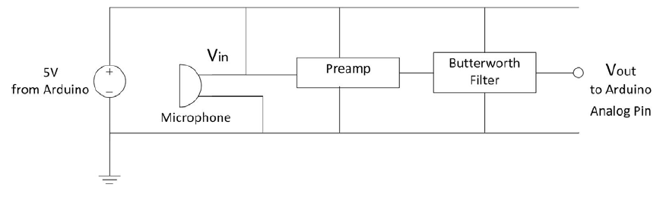

Figure 57: Overview Circuit of Amplification and Filtering

### Analog Preamplification

A preamplifier is used to prepare the microphone signal for further amplifying, filtering, and processing. First, a low noise audio operational amplifier (op-amp) was chosen to determine the preamplifier. The following op-amps were chosen for their high quality characteristics and reputation for use in audio applications, as well as their low-to-medium price points to keep the device affordable: NE5532, TL072 The TL072 and NE5532 require an adequate supply voltage that can be powered by a 9V battery or by the 5V from the Arduino. That concludes the photos for the schematics:

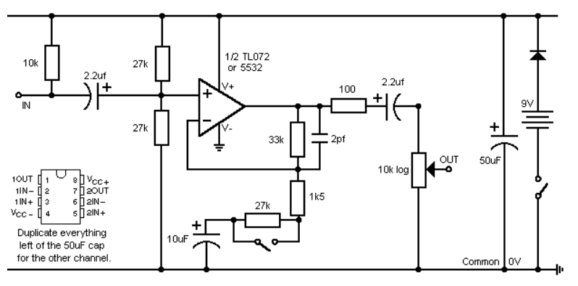

Figure 58: ECG Pre-Amplifier Circuit

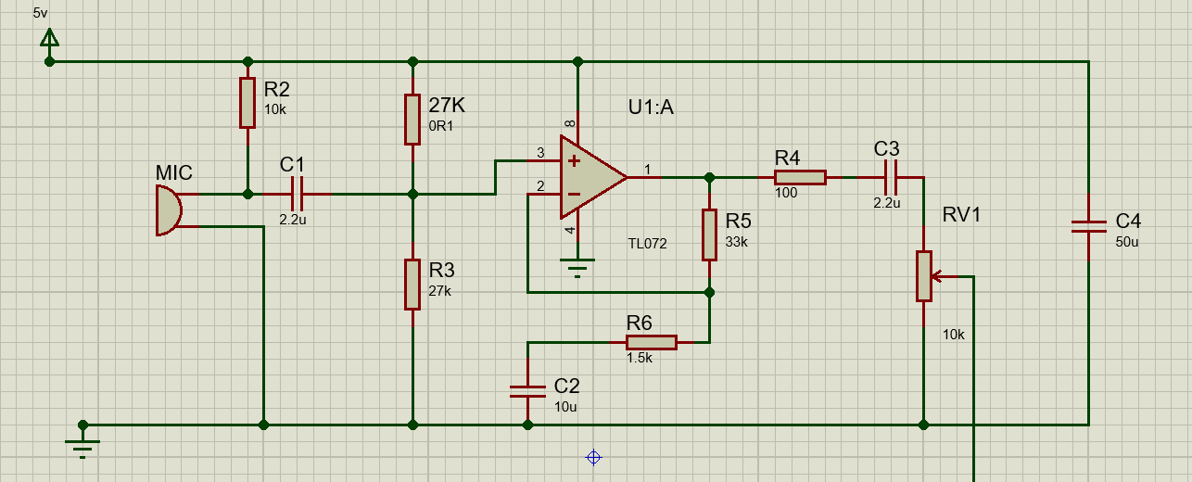

Figure 59: ECG Pre-Amplifier Circuit on Proteus

### Analog Signal Filtration

Sampling is the process of converting an analog continuous-time signal into a discrete numerical sequence that can be processed digitally. For the signal to be perfectly reconstructed, the sampling rate frequency must be at least double the highest frequency of the band-limited signal's upper limit [8].

The Butterworth filter is the most common anti-aliasing filter used in audio applications where specific signal response is required across the circuit's bandwidth. This is largely because the Butterworth filter has the least amount of attenuation across its pass region, resulting in the least distortion of the signals that are passed. The Butterworth filter is a higher order filter composed of a series of cascading first or second order filters. Professor Hall confirmed the use of the Sallen-Key filter. He proposed that several Sallen-Key filters be used to improve the response's gain roll-off. With a higher gain roll-off, signals above the cut-off frequency are reduced by a greater magnitude. That concludes the photos for the schematics:

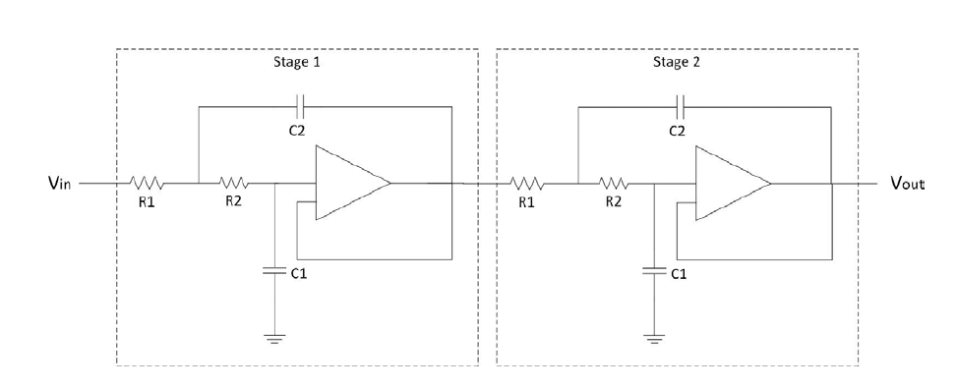

Figure 60: Butterworth Filter

COG-type ceramic capacitors with tolerances ranging from 0.25 pF to 1% for higher values are the most precise capacitors available in the range of 0.5 pF to 47 nF. [9]. X7R-type ceramic capacitors have a tolerance of +1% and range from 100pF to 2.2F. Tantalum electrolytic capacitors have the lowest tolerance for values greater than 2.2 F. National Semiconductor recommends that resistor values be between 1 k and 100 k, and capacitor values be between 1nF and several F.

The most important characteristic in selecting the appropriate operational amplifier used in the filter was the unity gain bandwidth. The open loop gain of the op amp should be 100 times greater than the peak gain of the filter for a maximum gain error of 1%. The maximum bandwidth required, as shown in Appendix IV, is 24 kHz. Another important parameter to consider is the slew rate, and the chosen op amp must have a slew rate greater than 3.14 V/ms. The LM741 op-amp was chosen as the op-amp for both Sallen-Key filters because it fits the given parameters and is widely available.

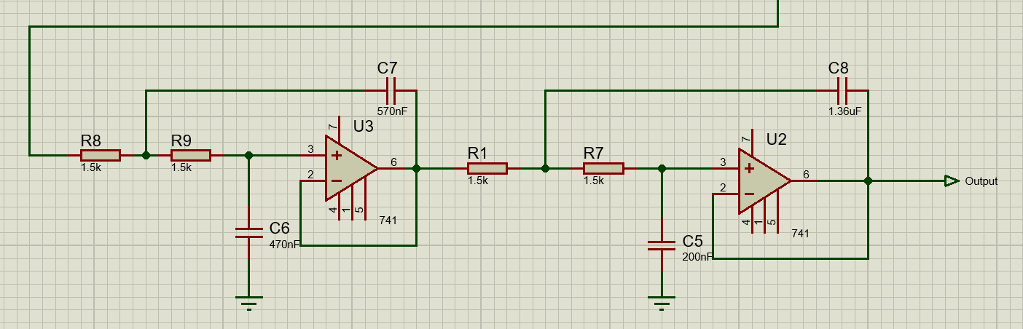

Figure 61: Butterworth Filter on Proteus

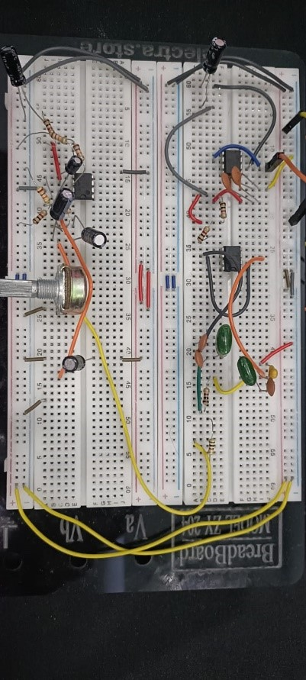

Figure 62: Final ECG Circuit on Breadboard

## PPG

### Band design

#### Concept Generation and Selection

Concept generation began with a breakdown of the function of the device shown in Figure 32.

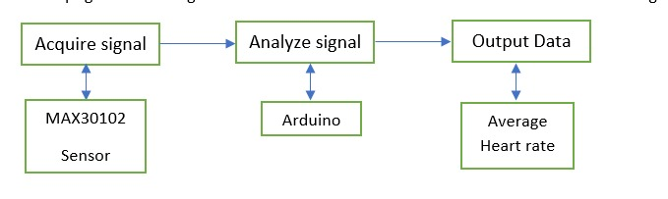

Figure 63: PPG Band Concept

First, the device is worn in the hand like a watch and is used to measure the ppg signals of the max30102 sensor, then sends those signals to a microcontroller by using i2c communication protocol to analyze those signals and identify the heartbeat. Based on the inputs, the person’s condition is determined by whether he is sleepy or not, then those signals will be sent to the master microcontroller of the system by using a Bluetooth module attached to the band.

First, brainstorming sessions for the method of signal detection were held, and a main concept was chosen.

#### Detect Signals

To determine the heartbeat, the MAX30102 sensor was chosen due to a lot of data such as its tiny size 5.6mm x 3.3mm x 1.55mm, Ultra-Low Power Operation for Mobile Devices operates on a single 1.8V power supply and a separate 3.3V power supply for the internal LEDs. , Low-Power Heart-Rate Monitor, -40°C to +85°C Operating Temperature Range.A standard I2C-compatible interface is used for communication.

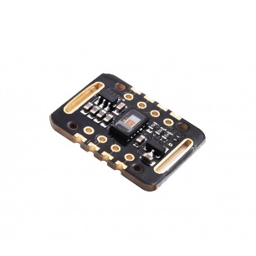

Figure 64: Max30102 Sensor

#### Analyze Signal

* Arduino Nano was chosen due to its small size when placed on the hand and the ease of programming it in the C language and the presence of a signal converter from analog to digital and finally because it shares with the sensor the Low power operation (5 volts) and finally because it also shares with the sensor in the presence of standard I2C-compatible interface is used for communication.
* To operate the band a battery is needed, choosing the Lipo Rechargeable Battery as it has 2.5 hours of charging time and it's able to work for 2-5 hours.
* To recharge the battery, the Micro USB 5V 1A TP4056 Lithium Battery Charger Module is selected since the operating conditions are the same between the driver and the battery.

#### Output data

* After analyzing those signals coming from the sensor through the controller, they are sent to the main controller in the system to take the necessary measures aimed at protecting the person who wears that band.
* Moreover, finding that the most suitable thing for sending this data is Bluetooth, specifically the UART, due to its high speed, in which its baud rate reaches 115200, and also due to the small distance between the band wearer and the main controller.
* Choosing the HC05 Bluetooth module, which is designed for wireless communication, having a range of up to <100m which depends upon transmitter and receiver, atmosphere, geographic, and urban conditions.

### Noise Filtrations

The sensor readings were found to have high noise and distortion, which prevented accurate analysis and interpretation of the obtained data. An IIR (Infinite Impulse Response) filter was used as a method to address this difficulty. The IIR filter was chosen because of its ability to efficiently reduce undesired frequency components while keeping signal information. The project successfully minimized noise and enhanced the accuracy of sensor signals by installing the IIR filter, allowing for more accurate data processing and interpretation for future research and applications.

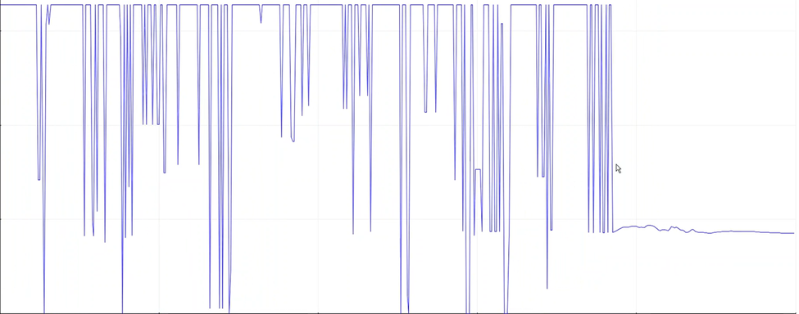

Figure 65: Signal Noise

### IIR Filter

An Infinite Impulse Response (IIR) filter is a type of digital filter used in signal processing and digital signal analysis. It is dubbed "infinite" because its impulsive reaction lasts eternally. In contrast to FIR filters, which have a finite impulse response, IIR filters use feedback in their implementation. This feedback enables IIR filters to include feedback channels in their output, resulting in a more complicated response.

One of the primary benefits of IIR filters is their efficiency. They require fewer filter coefficients to obtain a same frequency response than FIR filters, making them computationally more efficient. This benefit is especially significant in real-time applications with limited computational resources.

The transfer function, which determines how the filter processes the incoming signal, distinguishes IIR filters. The transfer function contains zeros and poles. Zeros are frequencies where the filter's response is zero, while poles are frequencies where the filter's response is infinite or unstable. The positioning of these zeros and poles influences the form and properties of the filter's frequency response.

### Code Concept

First of all, the program check for the beat if beat found it will wait to other beat and calculate the time between them, it will continue if the time between beats is more than 300ms if not it will back again to check for beat, after calculate the time between them it will calculate the beat per minute according to the equation in figure.

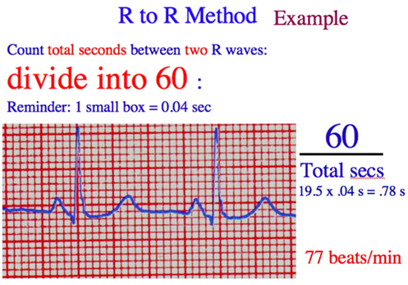

Figure 66: R - R Method

Code will repeat this function 50 time in one minute to collect 50 indexes in an array after collecting them it will calculate the average of them.

At the beginning we aim to get reference value for the driver at start of the trip & compare it with his current beat per minute to determine its state.

So, we make a function to wait for 5 minutes after he start the trip to ensure that his vital organs are calm and his heart rate is stable due to the effort exerted on him until he reaches the car, so that the comparison between the initial value and the current value is accurate.

The function after 5 minutes from start the trip take a value and put it into array of 2 values then it will wait again for another 5 minutes and take value again and put it in the second index in the array and compare between the first value & the second if the difference between them is more than 5 it means that His heartbeat decreased and the driver's condition turned back to normal And the difference of five values is a logical value that can express the driver's transformation from the state of simple stress caused by walking to reach his car and his calmness in the driving seat at the start of the trip. , and we can rely on this value when compared to the driver's condition throughout the road, and if the difference less than 5 this process will repeat itself again until reach desired target.

And above all, the values and signals are filtered, as we talked about earlier, by using IIR filter to ensure that the values are reached to the highest levels of accuracy.

After reaching a value that we can rely on in the comparison between the initial value and the current value of the driver, the program, over the course of wearing the band, compares them and determines its condition based on the experiments that we carried out on different people and different ages, through which we were able to determine the values of the person’s heartbeat transition from one state to another

### Testing

Testing the band on eight test subjects (6 males, 23 and male, 59 and female 45) without any heart diseases for an hour at bedtime, the embedded ppg sensor continuously recorded the subject's biomedical signal.

The subjects were not sleepy at all at the beginning and the body movement was active whereas, at the end, the subjects appeared very sleepy, with frequent yawning and deep respiration.

The time when the subjects felt fatigued and drowsy was recorded and used to extract the recorded ECG signals for condition evaluation using an Arduino plotter.

So for the first subject, founding that at his normal state, the average heart rate is about 75 (beats/min) as shown in Figure 34.

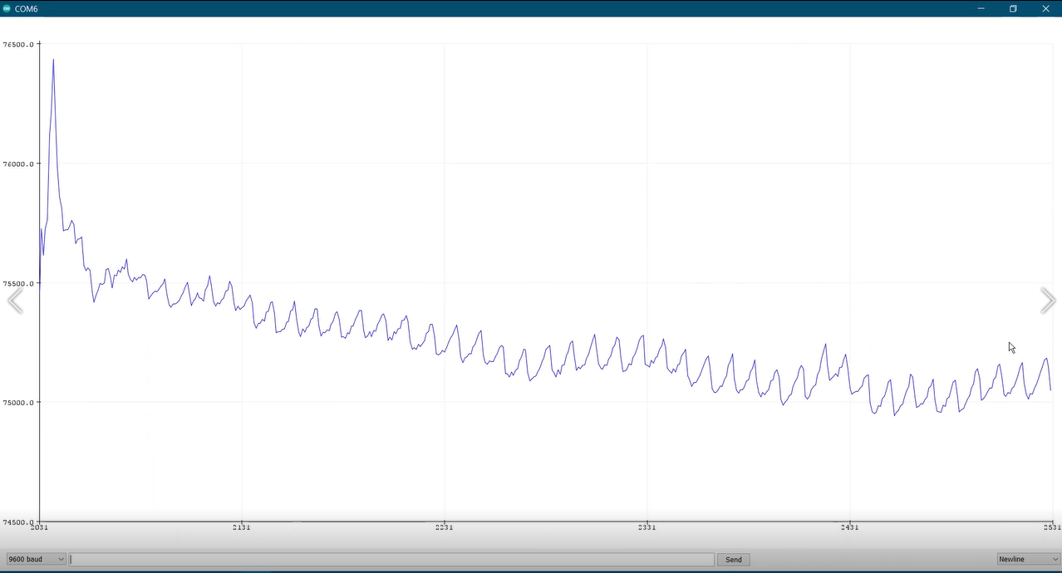

Figure 67: PPG Band Result in Normal State

The second trace shows the ppg signals for the same subject in a fatigued state and the calculated HRV and we found that the beat decreases by about 66 (beat/min) as shown in Figure 35 below.

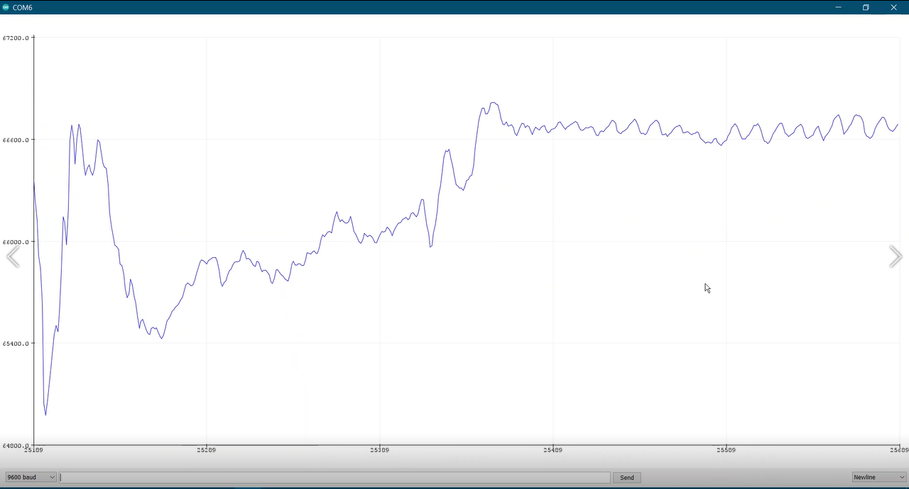

Figure 68:PPG Band Result in Fatigued State

The last trace shows the ppg signals measured when the subject was in a drowsy state and its HRV is about 55 (beat/min) as shown in Figure 36 below.

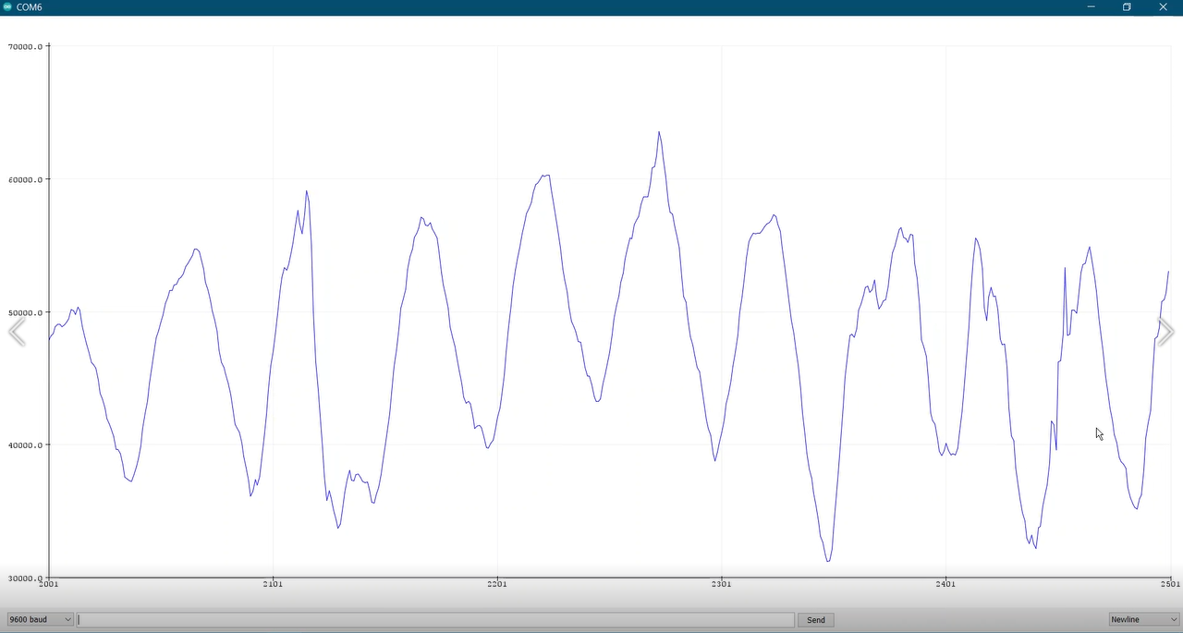

Figure 69: PPG Band Result in Drowsy State

Table 9 shows the heart rate (beat/min) of the two cases that were tested, as explained previously the first subject was male at 22 years, and the second male at 59.

Table 16: BPM Results

|  |  |  |  |  |
| --- | --- | --- | --- | --- |
| Subject | Age | Normal  BPM | Fatigued  BPM | Drowsy  BPM |
| 1 | 23 | 75 | 66 | 55 |
| 2 | 23 | 80 | 68 | 59 |
| 3 | 59 | 69 | 63 | 57 |
| 4 | 23 | 72 | 65 | 60 |
| 5 | 23 | 75 | 70 | 62 |
| 6 | 23 | 85 | 77 | 68 |
| 7 | 23 | 71 | 67 | 62 |
| 8 | 45 | 73 | 65 | 59 |

Table 17: BPM Data Chart

Based on this data, we noticed that the human condition changes based on the change in his heartbeat, and the amount of change varies between each case and another between 7 to 10 beats.

### Concept Description

The band consists of a sticker that contains the controller, Bluetooth, battery, charger, and sensor, as shown in Figure 37 below.

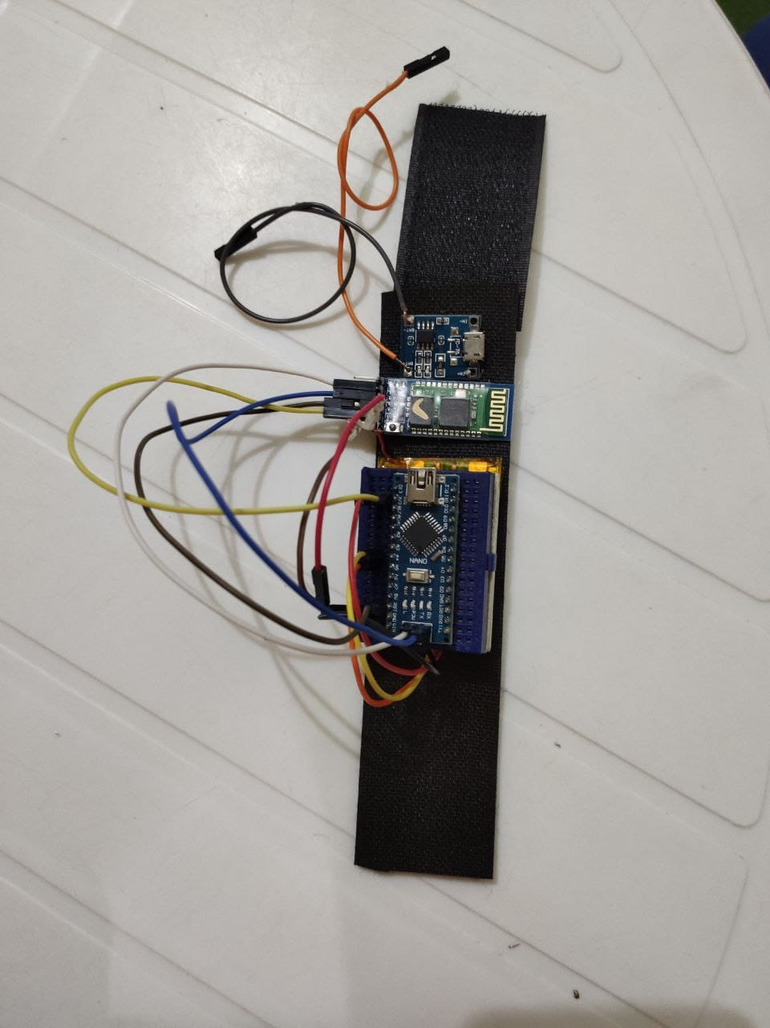

Figure 70: Our PPG Band

# Conclusion & Future Work

In conclusion, the project demonstrates a comprehensive approach to improving driver safety by detecting drowsiness and potential distractions. By combining various features, such as eye aspect ratio, mobile detection, PPG band, steering wheel detection, and pose estimation, the project offers a holistic solution for mitigating the risks associated with driver fatigue.

The successful implementation of these features in the project demonstrates the potential of advanced technologies like computer vision and physiological monitoring in improving driver assistance systems. The ability of the system to monitor critical sleepiness and driver engagement indicators gives crucial real-time feedback, allowing drivers to take appropriate steps and avoid potential accidents.

In terms of future work, many strategies might be implemented to improve the system's effectiveness and applicability. One possible area for future study may be the incorporation of machine learning methods to improve drowsiness detection accuracy and reduce false alarms. Incorporating additional sensors or data sources, such as facial expression analysis or vehicle data, could also provide a deeper awareness of driver behavior and aid in the improvement of the system's responsiveness. Furthermore, broadening the system's capacity to handle other driver-related dangers, such as attention detection outside cell phone use, could provide a more comprehensive approach to overall driver safety. Integrating modern communication technologies, such as vehicle-to-vehicle or vehicle-to-infrastructure connectivity, could improve the system's ability to deliver timely warnings and alerts. also, by incorporating advanced autonomous driving capabilities, the system could detect signs of driver fatigue and initiate an automated parking sequence, ensuring the safety of both the driver and other road users.

Overall, the project's achievements in developing an advanced driver assistance system for drowsiness detection lay a strong foundation for future research and innovation in this field. By continuously refining and expanding the system's capabilities, we can strive towards creating safer road environments and reducing the occurrence of accidents caused by driver fatigue.

# Gantt Chart

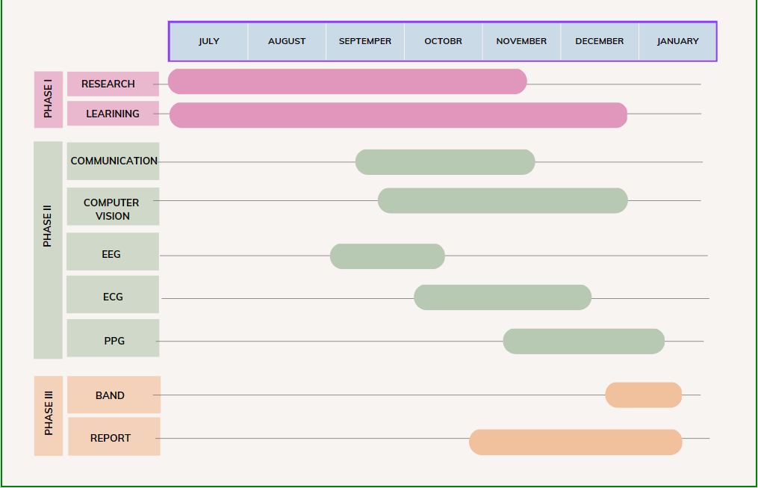

# References

|  |  |
| --- | --- |
| [1] | CAPMAS, "The Annual Bulletin Results of Car & Train Accidents 2021," Central Agency for Public Mobilization And Statistics, Egypt, 2022. |
| [2] | W. Tipprasert, T. Charoenpong, C. Chianrabutra and C. Sukjamsri, "A Method of Driver’s Eyes Closure and Yawning Detection for Drowsiness Analysis by Infrared Camera," in *2019 First International Symposium on Instrumentation, Control, Artificial Intelligence, and Robotics (ICA-SYMP)*, Bangkok, Thailand, IEEE, 2019, pp. 61-64. |
| [3] | N. Alioua, A. Amine, M. Rziza, D. Aboutajdine and A. Amine, "Driver’s Fatigue and Drowsiness Detection to Reduce Traffic Accidents on Road," in *Computer Analysis of Images and Patterns. CAIP 2011. Lecture Notes in Computer Science*, Berlin, Heidelberg, Springer, 2011, pp. 397-404. |
| [4] | S. Majumder, B. Guragain and C. Wang and N. Wilson, "On-board Drowsiness Detection using EEG: Current Status and Future Prospects," in *2019 IEEE International Conference on Electro Information Technology (EIT)*, IEEE, 2019, pp. 483-490. |
| [5] | Jung, Sang-Joong and Shin, Heung-Sub and Chung and Wan-Young, "Driver Fatigue and Drowsiness Monitoring System with Embedded Electrocardiogram Sensor on Steering Wheel," *Intelligent Transport Systems, IET,* vol. 8, pp. 43-50, 2014. |
| [6] | D. Castaneda, A. Esparza and Ghamari M, "A review on wearable photoplethysmography sensors and their potential future applications in health care," *International journal of biosensors & bioelectronics,* vol. 4(4), pp. 195-202, 2018. |
| [7] | Rajput, Poonam and Nag, Subhrajit and Mittal and Sparsh, "Detecting Usage of Mobile Phones using Deep Learning Technique," 2020. |
| [8] | Diniz, S. R. Paulo, A. B. Eduardo, DaSilva and L. Sergio, " Digital Signal Processing: System Analysis and Design," Cambridge, U.K.: Cambridge UP, 2002. |
| [9] | Kugelstadt and Thomas, "Active Filter Design Techniques," in *Chapter 16. Texas Instruments*, 2012. |